ngnTITLE PAGE
A WEB-APP COURSE RECOMMENDATION AND CAREER GUIDANCE SYSTEM FOR GRADE 12 STUDENTS OF ARCELO MEMORIAL NATIONAL HIGH SCHOOL
A Capstone Project
Presented to the Faculty of the
Bachelor of Science in Information Technology
Cebu Technological University – Consolacion Campus
In Partial Fulfillment
of the Requirements for the Degree
Bachelor of Science in Information Technology
by:
NACILLA, JENHO
PERAAN, RONA MAE
CELESTIAL, ODIZA
MANTUHAC, CHRIS DANIEL
SANDOY, LLOYD CRISTIAN
January 2026

APPROVAL SHEET

This capstone project entitled "A Web‑Based Course Recommendation and Career Guidance System for Grade 12 Students of Arcelo Memorial National High School" prepared and submitted by Jenho Nacilla, Rona Mae Peraan, Odiza Celestial, Lloyd Cristian Sandoy, and Chris Daniel Mantuhac in partial fulfillment of the requirements for the degree of Bachelor of Science in Information Technology, Cebu Technological University – Consolacion Campus, has been examined and is recommended for approval and acceptance.

CAPSTONE ADVISORY COMMITTEE
KRYSTEL JANE I. AJIAS, M. Ed (CAR)
Chairperson
__________________________
PANEL OF EXAMINERS
Approved by the Committee on Research Proposal with a grade of __________

PROF. RRJ NOYA CAPUNO
Chairperson

KRYSTEL JANE I. AJIAS GREG C. VESTIL
Member Member
JUAN M. HEREDIA JAMAICA BURGOS
Member Member
Accepted and approved in Partial fulfillment of the requirements for the degree of Bachelor of Science in Information Technology.

Date of Proposal Hearing :
Date of Oral Examination :

Sarah Jean Colina
Dean

ACKNOWLEDGEMENT

We thank God for the guidance and endurance that carried this project to completion. To the Arcelo Memorial National High School, we are very much thanking you for welcoming this project and letting us do our research.
.

To Prof. Rrj Noya Capuno, we would also like to thank you for supporting us, your students, and fulfilling your job to provide assistance and consideration whenever you can. To all the panelists, we are very much happy for your honest criticisms and feedbacks that pushed us to refine our capstone system.

To our families and friends, your unwavering support gives us hope that we so much needed to finish the capstone and pushed us to our limits.

The Researchers

DEDICATION

To the Grade 12 students of Arcelo Memorial National High School—may this platform soon guide you all toward choices that honor your aspirations.

To the future guidance personnel who will steward student journeys—may your forthcoming stewardship shape confident, purposeful graduates in the future.

To our families—thank you for the unwavering faith and support that sustained this meaningful endeavor.

TABLE OF CONTENTS
TITLE PAGE 1
APPROVAL SHEET ii
ACKNOWLEDGEMENT iii
DEDICATION iv
Chapter I 1
INTRODUCTION 1
Rationale of the Study 1
Objectives of the Study 2
Specific Objectives: 3
Scope and Limitation of the Study 4
Scope of the Study 4
Limitation of the Study 4
Significance of the Study 5
Flow of the Study 7
Definition of Terms 9
CHAPTER II 10
REVIEW OF RELATED LITERATURE AND STUDIES 10
Locale 10
International 10
REVIEW OF RELATED STUDIES 11
Locale 11
International 11
Comparative Matrix 12
CHAPTER III 15
RESEARCH METHODOLOGY 15
Environment 15
Software Engineering Methodology 16
Planning Concept / Initiation Phase 18
Business Model Canvas ( BMC ) 18
Program Workflow 19
Validation Board 21
Gantt Chart 22
Functional Decomposition Diagram 23
Analysis Design Phase 24
Use Case Diagram 24
Storyboard 26
Entity Relationship Diagram 41
Data Dictionary 42
Network Design 50
Network Model 50
Network Topology 51
Development / Construction / Build Phase 52
Technology Stack Diagram 52
Frontend 53
Backend 53
Database 54
Server Environment 54
Software Specifications 54
Hardware Specifications 55
Program Specifications 55
List of Modules 55
Testing/Quality Assurance Phase 58
Unit Testing 58
Student Module 59
Counselor Module 60
Alpha Testing 63
ALPHA TESTING 63
Chapter IV 67
SUMMARY OF FINDINGS, CONCLUSIONS, AND RECOMMENDATIONS 67
References 69
CURRICULUM VITAE 72
PSYCHOMETRICIAN CERTIFICATION 78

LIST OF TABLES
Table 1: Comparative Matrix
Table 2: Validation Board
Table 3: Gantt Chart - Timeline
Table 4: Data Dictionary - Activity Logs Table
Table 5: Data Dictionary - Assessment Questions Table
Table 6: Data Dictionary - Assessment Schedules Table
Table 7: Data Dictionary - College Courses Table
Table 8: Data Dictionary - Counselor Notes Table
Table 9: Data Dictionary - Student Assessments Table
Table 10: Data Dictionary - Course Recommendations Table
Table 11: Data Dictionary - Deleted Assessment Students Table
Table 12: Data Dictionary - Security Settings Table
Table 13: Data Dictionary - Settings Table
Table 14: Data Dictionary - Student Answers Table
Table 15: Data Dictionary - Users Table
Table 16: Data Dictionary - Software Specification Table
Table 17: Hardware Specifications Table
Table 18: List of Modules
Table 19: Unit Testing
Table 20: Alpha Testing
Table 21: Acceptance Testing

LIST OF FIGURES
Figure 1: Flow of the Study
Figure 2: Map of Arcelo Memorial National High School
Figure 3: Software Development Model
Figure 4: Business Model Canvas
Figure 5: Program Workflow – Grade 12 Student
Figure 6: Program Workflow – Guidance Counselor
Figure 7: Functional Decomposition Diagram
Figure 8 : Use Case Diagram - Grade 12 Student
Figure 9 : Use Case Diagram - Guidance Counselor
Figure 10: Guided Route Login Page
Figure 11 : Guidance Counselor Dashboard
Figure 12: Career Profile Card
Figure 13: Career Profile Card – Batch Export
Figure 14: Career Profile Card – Delete Student
Figure 15: Career Profile Card – PDF Profile Career Card
Figure 16: Career Profile Card – Undo Deletion
Figure 17: Student Career Assessment Registration Form
Figure 18: Assessment Instructions and Guidelines
Figure 19: RIASEC Assessment Question Interface
Figure 20: Assessment Completion Confirmation
Figure 21: Course Recommendations Results
Figure 22: Add New Schedule Modal
Figure 23: Assessment Schedule Management
Figure 24: Analytics Dashboard
Figure 25: Student Progress Monitoring
Figure 26: Student Profile Details
Figure 27: Add Counselor Note
Figure 28: System Administration and Settings
Figure 29: Advanced Security Configuration (Settings)
Figure 30: ERD
Figure 31 : Network Model
Figure 32: Network Topology
Figure 33: Technology Stack Diagram

Chapter I

INTRODUCTION

Rationale of the Study

Grade 12 students at Arcelo Memorial National High School pick their college courses without much structure behind the decision. The school has no formal guidance office, and there's no standardized process for helping students figure out where their aptitudes actually point before they commit to a track. In practice, most students go with what their parents expect, what their “barkada” is taking, or whatever course sounds stable—not because those are bad reasons, but because nothing else is available to weigh them against.

The Philippine K-12 curriculum assumes that SHS track choices feed logically into tertiary education and eventually into a career. That alignment matters, but it doesn't happen automatically. It requires students to have some, honest sense of their own interests and strengths before the decision gets made—and that's exactly what's missing at AMNHS. This system is a big help to institutions specifically Arcelo MNHS.

There are already some simple online test exams, but most of them requires discipline in answering and proper monitoring. Mostly of that kind of exams requires to have internet connection in which some students have a hard time to acquire. Students just take the test and when the result are out, they are still doubtful whether to follow the courses displayed on the screen or not.

Guided Route system has all the features needed for the struggling Arcelians. It can run offline in school’s local network so the internet connection is not really aproblem. It requires the students to answer the 100 item RIASEC-backed questionnaires, which scores automatically and provide a course recommendation based on their exam results. The administrator or the guidance counselor has all the access of the students’ results in their screen which avoided the reliance of manually checking time by time.

The huge difference with other existing systems comes after the results. For the manual process, exam results took too much time to score and also to compile reports. By using the Guided Route, student can quickly access their course recommendations and the guidance counselor has all the resources to monitor every results. That's one of the most important unique feature the system can offer without heavily relying to an internet connection.

The administrators/guidance counselor can give career advice with real data rather than guesswork, without spending time on manual checking each test results. For the students, that means the guidance they get about their future is actually reliable and accurate.

Objectives of the Study
This study builds the "Guided Route," a locally hosted web-app course recommendation system for the Grade 12 students of Arcelo Memorial National High School. The system requires the students a 100-item RIASEC assessment, then it will score automatically, and matches each student to many college courses here in the Philippines, which is very important for deciding the future that they will have.

Specific Objectives:
- The client or student side of the system is about:
- Complete a timed, 100-item digital RIASEC questionnaire that works offline and stores their responses securely.

- See personalized course recommendations right after finishing, based on their normalized trait scores.

- Download a career advisory showing their top matches, likely career paths, and how strong each match is.
.
- To be able to create an organized system with a clean backend for administering:
  - To acquire the recommendation method/engine that can normalize the scores and outputs to the top Philippine college courses with the use of the weighted compatibility pattern that is used by many existing online guidance exams.
  - To be able to build a strong knowledge containing program description, requirements, and also the range of the salary to be expected.
  - To deploy an organized admin dashboard which makes the admin able to study in real-time the assessment activities and also to monitor the recommendations easily.

Scope and Limitation of the Study

Scope of the Study

Guided Route has the fully assessment and proper reporting cycle for Grade 12 students at Arcelo which can possibly run with the help of the school’s local network.
Students will take the 100-item RIASEC assessment with timer of 15 seconds per question under the guidance of a personnel too. When the last question is answered, the system will quickly compute and give scores which leads to the top 3 most suitable college courses based on the student’s answers.
The side of the administrator is very much easy to fulfil. The assessment records can be quickly searched, they can also manage the activities and everything that’s going on real-time. Administrators has also the ability to restore and backup the database in case something would happen and then it will run completely without every worrying about not being able to have it.
.

Limitation of the Study
Guided Route system can only work in the campus. It can run on the school's LAN, so students cannot access it from their homes, and sessions have to be in the computer laboratory. The recommendations are only as good as the responses. The 15-second timer purpose is to discourage the rush, but the system has no any way to tell if that student is answering honestly or just clicking through without reading. Results from students who don't engage seriously will be very inaccurate, and there is nothing we can do to detect it.
.
The recommendation logic is also having flaws. It matches RIASEC profiles to college courses and that’s only matters. It doesn't consider like finances, environment or even the admissions requirements of the universities . A student might be given by the system a course that is expensive. Those conversations still have to happen with counselor. There's no machine learning. It doesn't include messaging or live chat between the students and counselors. And it requires someone qualified to be able to have run it can handle the system efficiently.
.

Significance of the Study
The study is very important to these people that has direct effect on the development of this Guided Route system.

Grade 12 students can benefit hugely with this system because it displays accuracy results based on their honest take on the exam. This is much easier to use and navigate compared to other existing online systems

Guidance Personnel also can benefit as it will not need any mechanical process or manual process. The admin side also is very easy to navigate and the layout is very clean. It has everything the admin needs to supervise the students taking it.
Parents and Guardians can also benefit because their students have now a clear path and supervision on what courses they will take based on their current technical skills, unlike when not using Guided Route, they can be potentially dragged by their friends to just take whatever course their friend took.
School Administration can deploy for the first time in any school to have a course recommendation for Grade 12 students only.

Flow of the Study
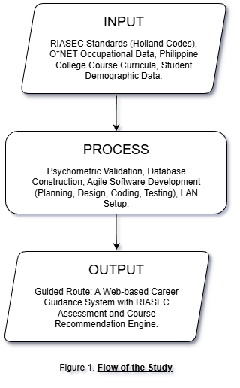

Input
This phase is composing the John Holland’s RIASEC standards, O*NET occupational data, and the list of all the active Philippine college courses right now. Important requirements were also student and worked on for the AMNHS administration.

Process
With the use of Agile Methodology, every data acquired is properly transformed and used into a functional system through unique design, coding, and repetitive testing. This includes validating the psychometric scoring logic and also to acquire scores with recommendations without bias.

Output
The result is "Guided Route," a locally hosted web application that is created to automate career assessments and generates valid, evidence-backed, course recommendations solely for the AMNHS Grade 12 students.

Definition of Terms
The terms are simply defined detailed for the readers to understand the system very well.
- Career Guidance System – refers to the "Guided Route" software application developed in this study that is created to automate the assessment and recommendation process only for the Grade 12 Students of Arcelo MNHS.
- RIASEC – is an acronym that stands for Realistic, Investigative, Artistic, Social, Enterprising, and Conventional; the six personality types defined by John Holland used as the framework for the assessment module that we are using.
- Local Area Network (LAN) – this refers to a private computer network within Arcelo Memorial National High School wherre the system will be deployed, ensuring access is restricted to on-campus devices only and not nationwide.
- Recommendation Engine – this represents the algorithmic component of the system that calculates compatibility scores between a student’s RIASEC profile and also from the database of college coursses.
- Psychometrics – refers to the measurement of mental traits; in this study, it shows the valid scoring and interpretation of the Grade 12 students' interests and aptitudes through the unique digital. questionnaire of Guided Route.
- Dashboard – is the administrative user interface that. allows guidance personnel to monitor student progress, to also manage records, and can also generate reports.

CHAPTER II

REVIEW OF RELATED LITERATURE AND STUDIES
Locale
DepEd Order No. 41 (2015) is requiring many schools to run a Career Guidance Program for the Grade 10 students, specifically to help them choose a suitable Senior High School track for them. The order applies even where counselor capacity is very thin. DepEd Memorandum No. 076 (2016) follows that up with the SHS Manual of Operations, which is simply saying tells out who does what for career guidance inside the schools. Both policies create an opening for something like our system Guided Route which is a school-based tool that is possible to run offline on a local network, handling mandated CGP activities without needing like any internet connections.
International
On the international side, Leung (2022) is carefully reviewing the computer-assisted career guidance systems and find out that the that digital tools can freeway the access, cut down decision difficulty, and to also help students get clearer on their options for college particularly when assessment results is direct. That shows directly onto how Guided Route is working, with its RIASEC-based assessment with recommendations. Waller et al. (2020), writing for IntechOpen on PK-12 online career guidance platforms, looked at systems like Kuder, Naviance, and Xello. They think that web-based tools improve counselor productivity and students’ future, but they can only work best with human guidance. That's the same logic behind positioning Guided Route with the counselor to counsel it.

REVIEW OF RELATED STUDIES

Locale
Maestrado and Bucar (2024) made the Career Guidance Advocacy Program in more or less 60 public schools (Bohol; n=1,200) and happened to found that counselor training, time, and resources could lead to weakened implementation where many students avoid following any NCAE results. This huge gap motivates automation and clean structured dashboard and this capabilities is provided by the system Guided Route we are making.
Agtani (2021) also similarly assessed CGP implementation in Benguet public schools, which he identifying training and also resource gaps, telling the urgent need for locally hosted tools that can deliver proper results despite their disadvantage in geographic locations.
International
Nadeem et al. (2023) built a web-based system that is able to collect student interests/aptitudes and then recommends careers with active market value information, which conveys the efficiency of automated, online guidance for the high school students which is almost similar to the Guided Route system.
Leung, Ho, and Heller (2022) also evaluated the Infinity CACGS and found out that the users reported lower decision difficulty and higher clarity than any non-users of the system, with effects varying by school and gender; these findings very much indicate that well-designed CACGS that can improve decision outcomes, aligning with Guided Route system.

Comparative Matrix
A Comparative Matrix defines is a comparison chart that can help readers to quickly see the similarities and differences between different things. It is a very straightforward way to check and differetiate information without going into so many details.

TABLE 1
COMPARATIVE MATRIX
Features | Description | Kuder Navigator | Naviance | Xello | Infinity CACGS | Nadeem et al. System | Guided Route
RIASEC Assessment | Integrated Holland-based interest inventory for career matching | ✓ | ✓ | ✓ | ✓ | ✗ | ✓
Offline/LAN Capability | System functions without internet connectivity via local network | ✗ | ✗ | ✗ | ✗ | ✗ | ✓
Automated Scoring | Real-time calculation of assessment results without manual intervention | ✓ | ✓ | ✓ | ✓ | ✓ | ✓
Course Recommendations | System-generated suggestions for college programs based on assessment | ✓ | ✓ | ✓ | ✓ | ✓ | ✓
Counselor Dashboard | Dedicated interface for guidance counselors to monitor student progress | ✓ | ✓ | ✓ | ✗ | ✗ | ✓
Student Progress Tracking | Tools to monitor individual student assessment completion and results | ✓ | ✓ | ✓ | ✗ | ✗ | ✓
Career Profile Cards | Visual summaries of student RIASEC codes with career path information | ✗ | ✗ | ✓ | ✗ | ✗ | ✓
Assessment Scheduling | Built-in calendar system for managing scheduled testing sessions | ✗ | ✓ | ✓ | ✓ | ✗ | ✓
Activity Logging | Security audit trail of counselor actions and system access | ✗ | ✓ | ✓ | ✓ | ✗ | ✓
Philippine SHS Tracks | Recommendations mapped to DepEd Senior High School track structure | ✗ | ✗ | ✗ | ✗ | ✗ | ✓
PDF Export/Printing | Generate printable reports for archiving and offline distribution | ✓ | ✓ | ✓ | ✗ | ✗ | ✓
Mobile Responsive | Interface adapts to smartphones and tablets | ✓ | ✓ | ✓ | ✗ | ✓ | ✗
TOTAL |  | 58% | 75% | 67% | 25% | 25% | 92%

CHAPTER III

RESEARCH METHODOLOGY
This chapter provides an overview of the methods and procedures researchers used in conducting the study. It encompasses the research environment, the software engineering methodology, and the various phases involved in the making of the project, such as the planning/concept initiation phase, development/construction/build phase, quality assurance. phase, and implementation/deployment phase that is essential in the development.

Environment
The study uses purposive sampling and direct observation as the two primary methods for collecting data. These activities aimed to assess the current career guidance capability of the school and identify the specific needs especially, in the Senior High School department. The study took place at Arcelo Memorial National High School, located in San Vicente, Liloan, Cebu.
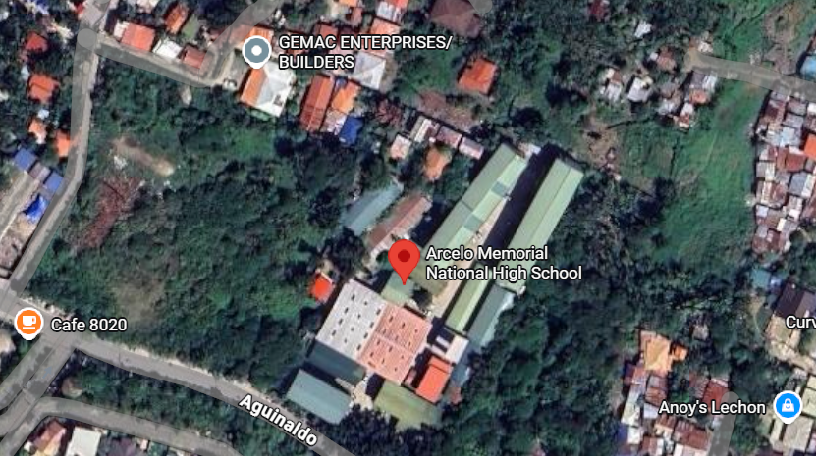
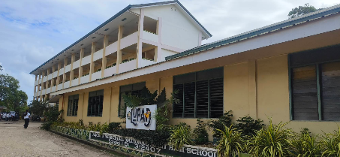

Figure 2: Map of Arcelo Memorial National High School

Software Engineering Methodology
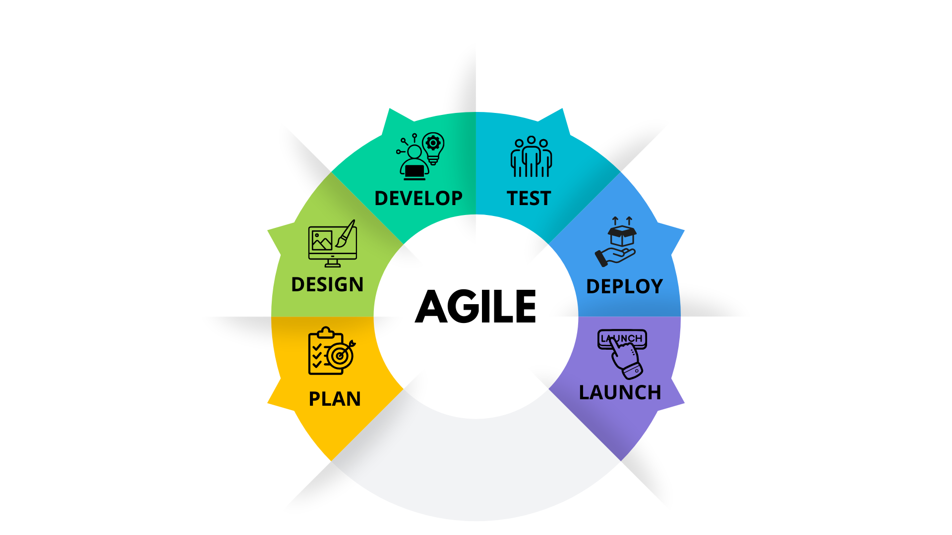
Software methodology is a clean structured approach to developing software, guiding the entire process from design to coding, testing, and also maintenance.
Figure 3: Software Development Model ( From left to right )

Agile is a way of building software in short cycles rather than planning everything upfront and delivering at the end which is commonly used from other systems. The logic is very simple as it requires change, and the later you catch with a wrong turn, then the more it costs to fix. Agile keeps the process much loose enough to change course without even starting over again.

The researchers picked the Agile because the Guided Route needs something to evolve through testings and with planning. Guidance counselors and Grade 12 students were our the primary users, and their input and how recommendations were displayed, how the tool fit into existing guidance sessions—could not be fully defined before development started. Working in short cycles, meant those details could be worked out as the system took shape, with adjustments made between sprints rather than patched in at the end.

The team used Agile because the project couldn't be fully planned in front. What the assessment should include is, how results should be shown, how the tool would fit into an actual guidance session of the system—those questions only had answers once real users started interacting with early versions of the system. Sprints kept development in very short, reviewable motion. When something needed changing, itjust simply went into the next cycle instead of becoming another problem at the end. Each sprint started with a specific target, which kept the work from reworking again and again.

Planning Concept / Initiation Phase
The planning and concept phase defined as the one that used to determine the problems that serve as the foundation for our development. In this phase, the researchers identified the core problems at Arcelo MNHS, and that is the lack of an automated guidance tool and also defined the project scope to address these needs properly.

Business Model Canvas ( BMC )
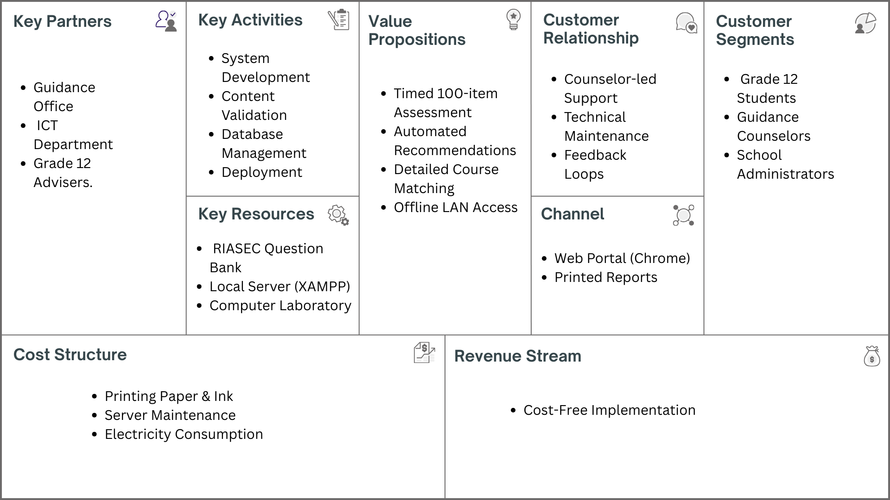

Figure 4: Business Model Canvas

Program Workflow
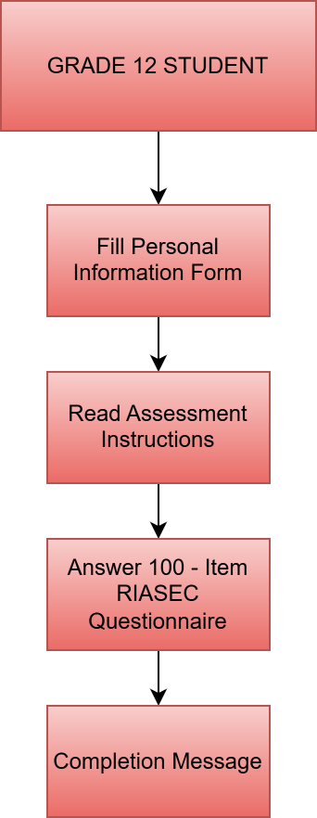
The program workflow is showing the program for such any particular user and to simplify the sequence and the flow of all the users.

Figure 5: Program Workflow – Grade 12 Student
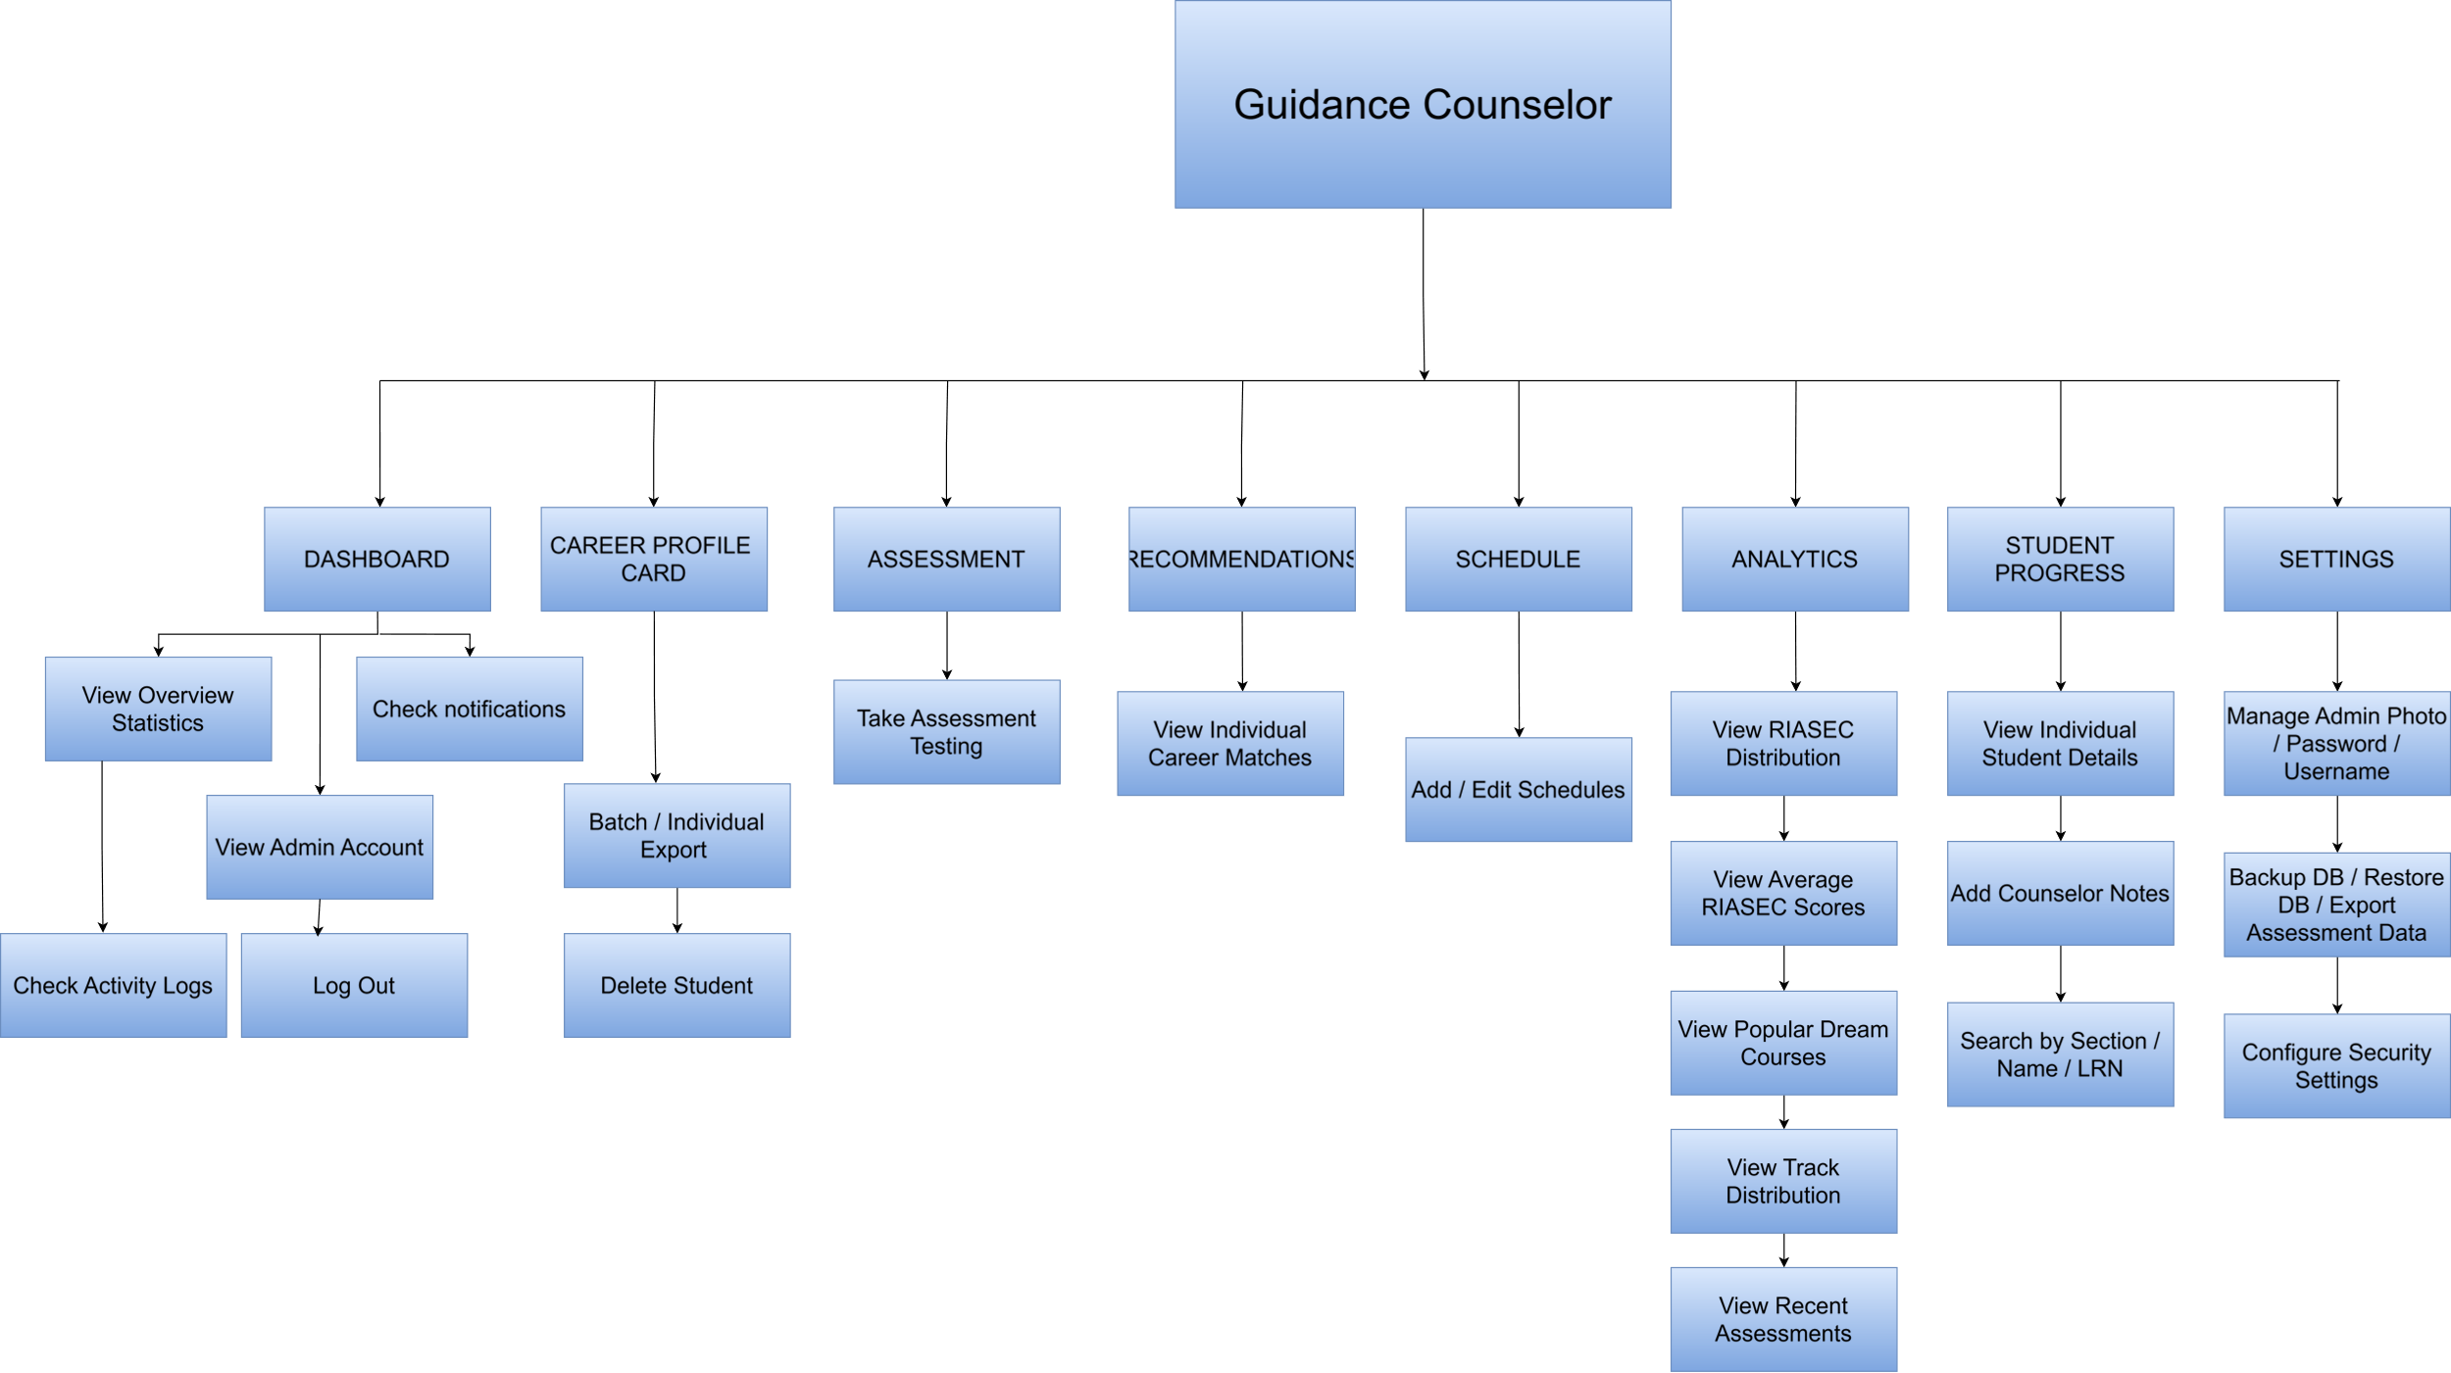

Figure 6: Program Workflow – Guidance Counselor

Validation Board
The figure below shows the validation board and the stakeholders, grade 12 students, and guidance counselor too.
Table 2
VALIDATION BOARD
Stakeholders | Grade 12 Students | Guidance Counselor
Problem | Students struggle to choose a college course due to a lack of objective self-assessment, and manual tests are tedious and prone to errors. | Mass assessments were used to slow the process, manual scoring can introduced errors, and generating individual career reports take a lot of time.
Solution | Provide a digital platform for an automated, interactive RIASEC assessment that gives instant, accurate course recommendations. | Providing a platform that makes automated scoring, data management of students, and generation of PDF careers.
Riskiest Assumption | Students will answer the 100-item questionnaire honestly and will find the digital interface easier to use than paper forms. | The system is able to handle the offline network and workload of school connection.
Success Criteria | 70% | 70%
Results | 7/10 = 70% valid | 7/10 = 70% valid
Learnings | Students appreciate immediate feedback and a modern interface, but require clear instructions for the 100-item length. | The system eases the job for the administrators.

Gantt Chart
This is the whole project timeline in developing the Guided Route system.

Table 3
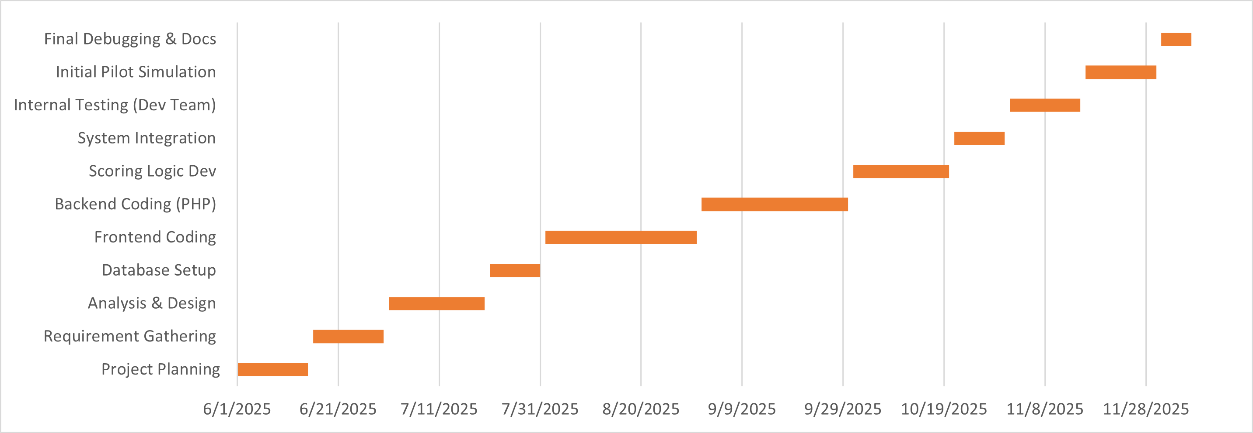
GANTT CHART

Functional Decomposition Diagram
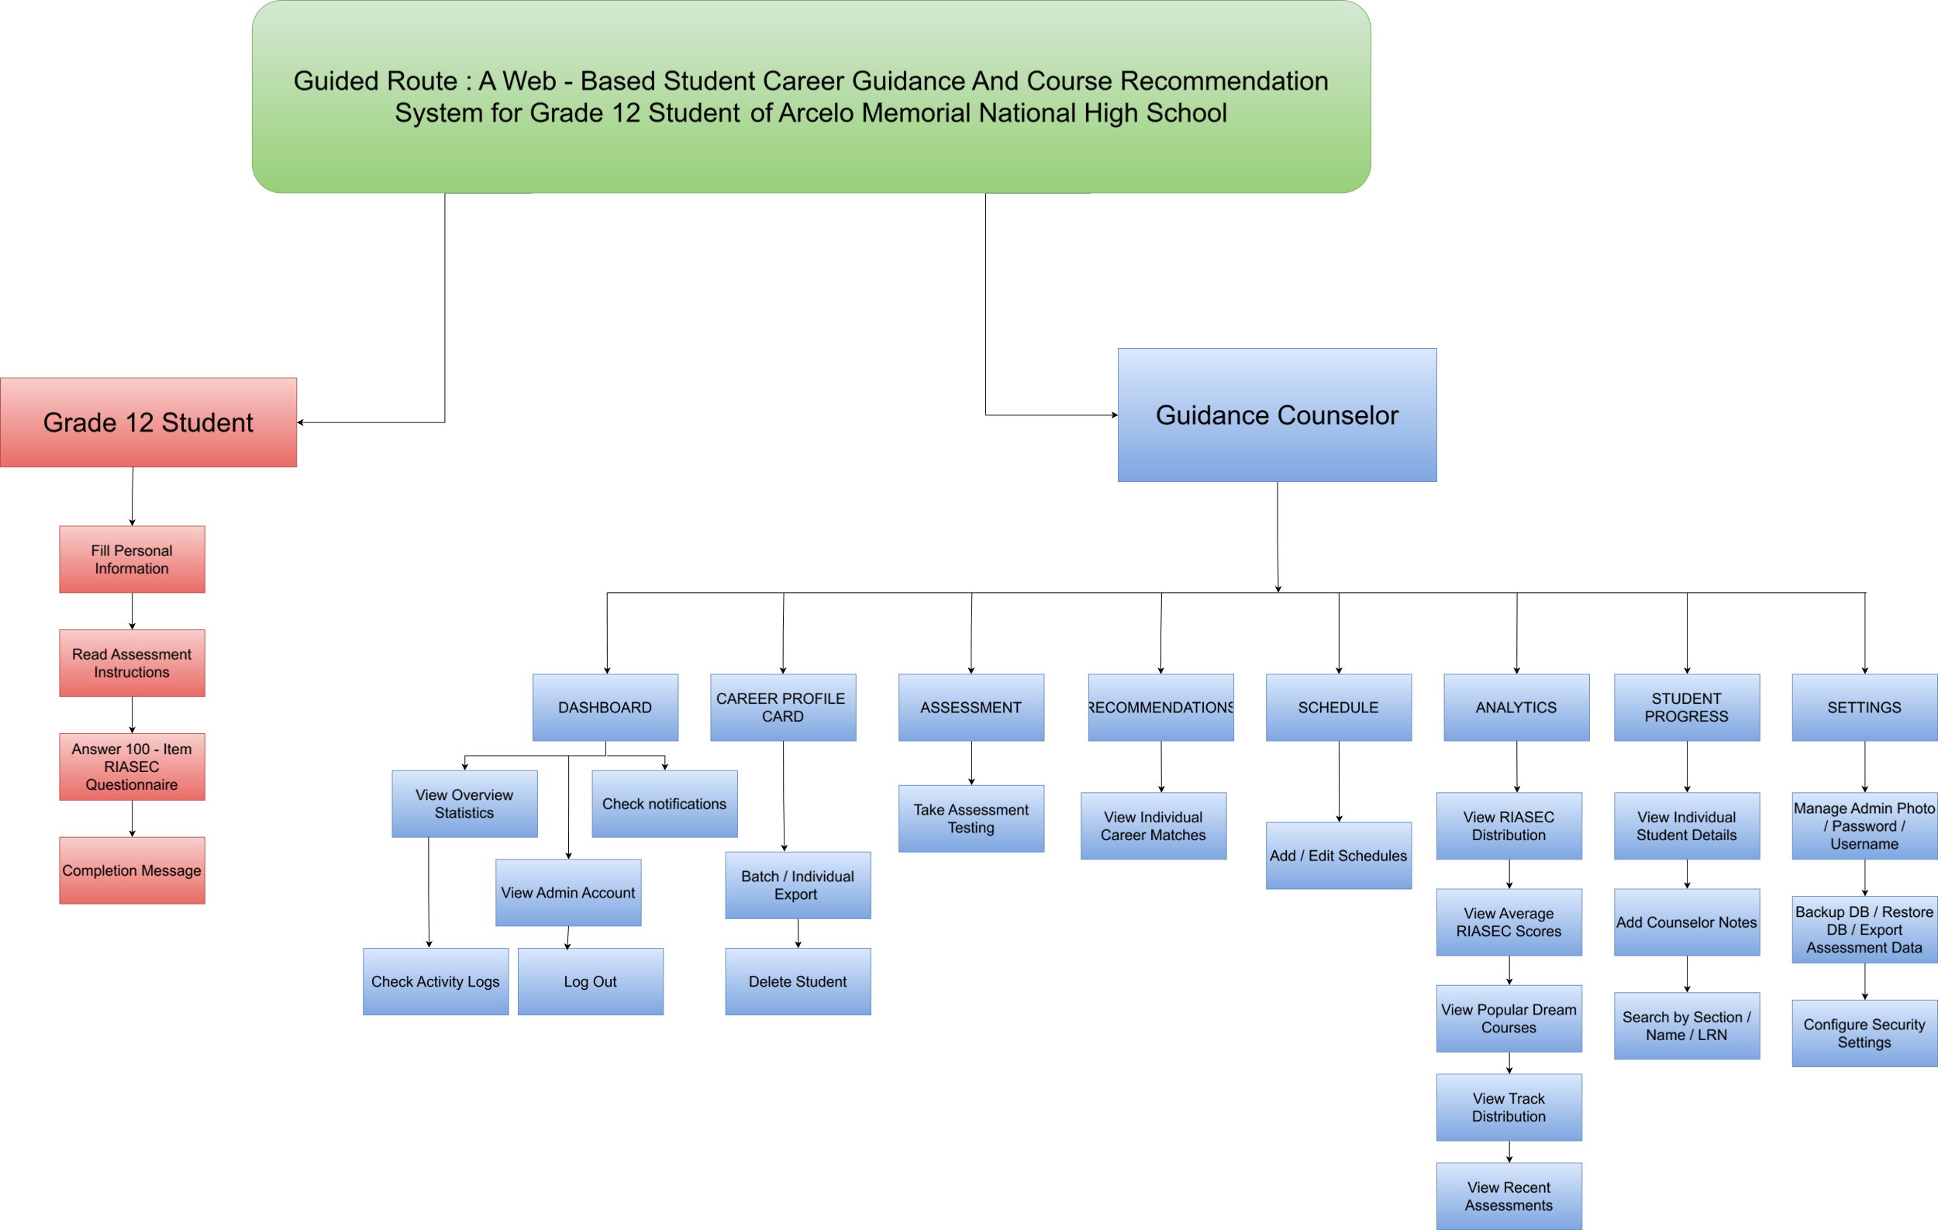

Figure 7: Functional Decomposition Diagram

Analysis Design Phase
The Analysis Design phase is the phase that combines the design with proper analytical studies.

Use Case Diagram
This shows the two primary users of Guided Route which is the Grade 12 students and admins.
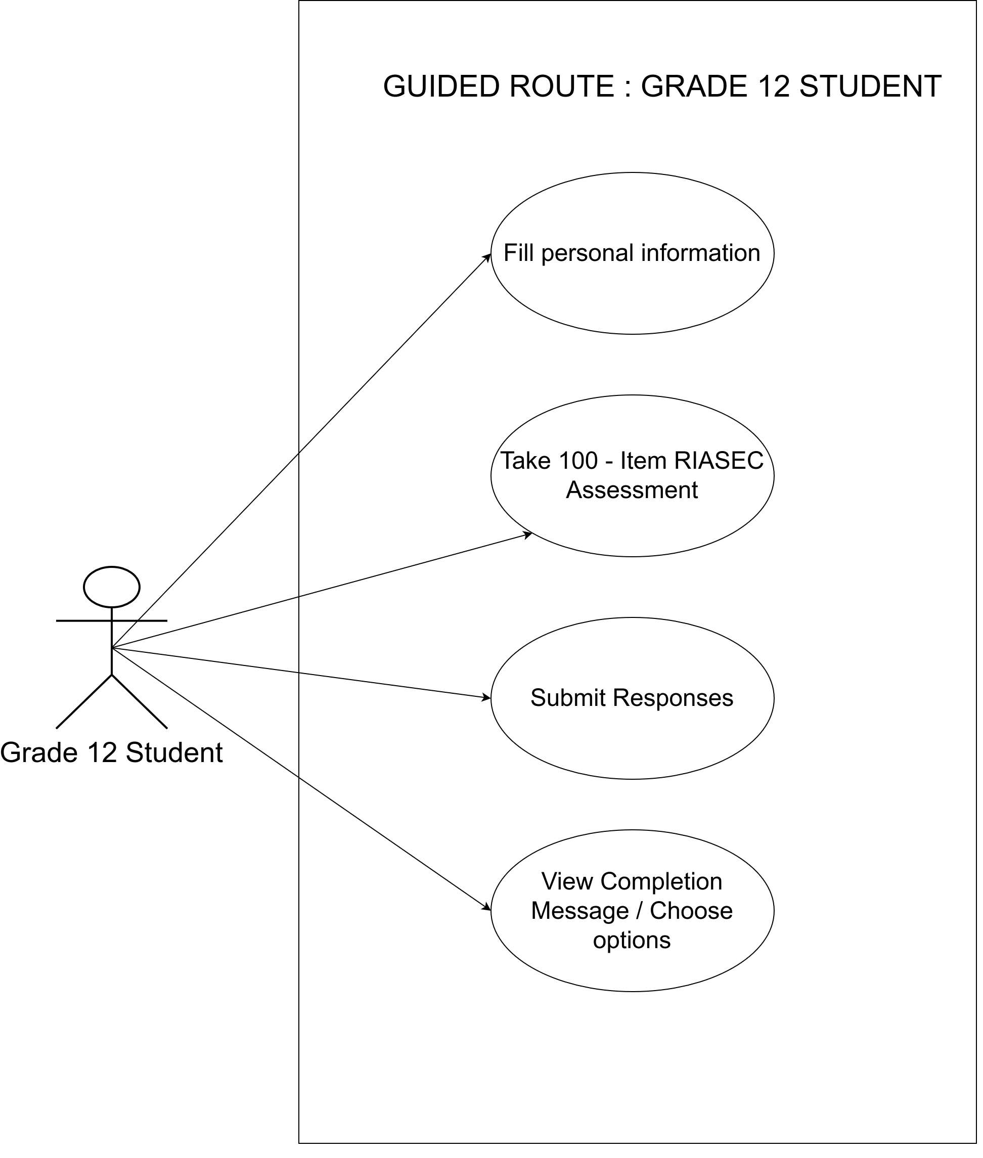

Figure 8 : Use Case Diagram

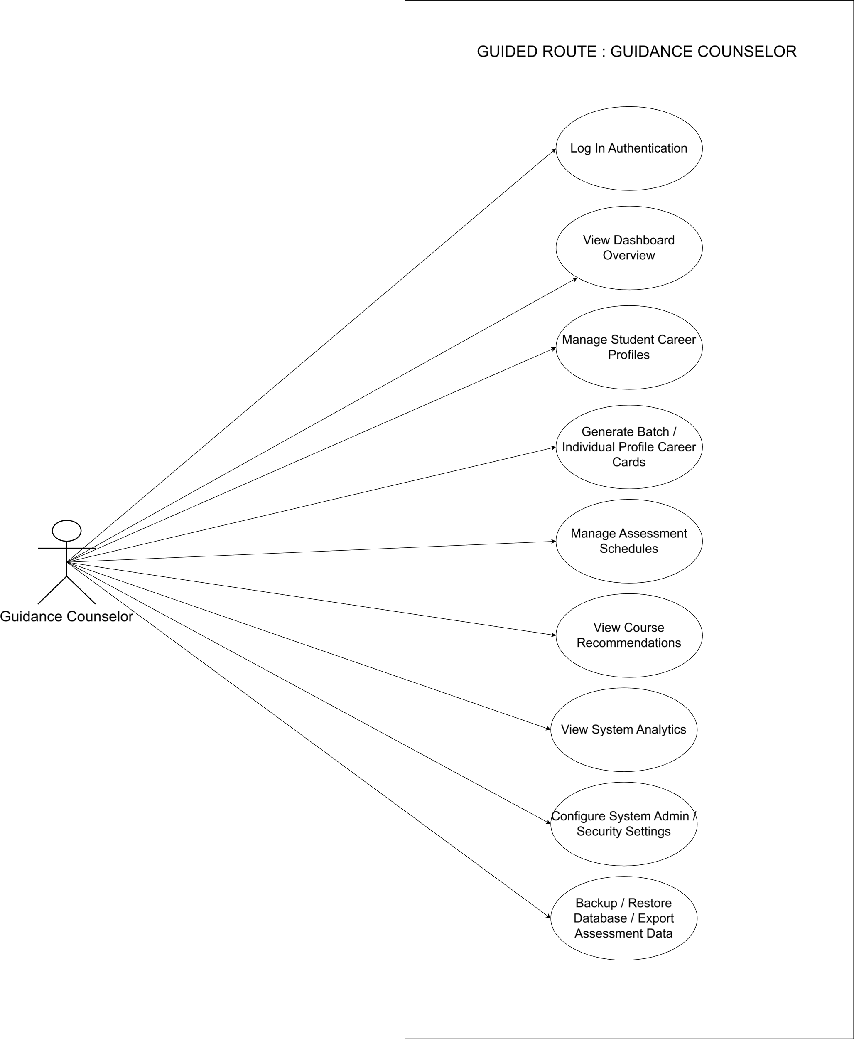
Figure 9 : Use Case Diagram

Storyboard

The studyboard is the tool used to illustrate our application and to support research in making and developing the system.

Figure 10: Guided Route Login Page

Guidance counselors log in with a username and password. After, they're taken to inside and to the administrative dashboard where the student records, analytics, and system settings are all accessible and displayed from there. The interface shows the school seal and "Guided Route" official logo.
.
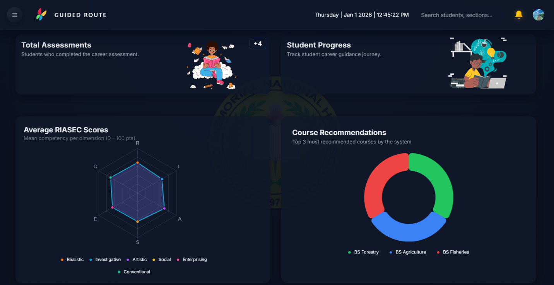
Figure 11 : Guidance Counselor Dashboard

The admin dashboard is the main screen counselors are seeing. In the header has three common elements which is a sidebar toggle, a search bar for searching up student records, and also live clock. A notification center will display newly scheduled sessions, and the profile menu also handles account settings.
It also shows the four containers such as total assessments, avg riasec scores, course recommendations, and also the student progress. It looks lively and its UI is properly planned by the researchers.
.

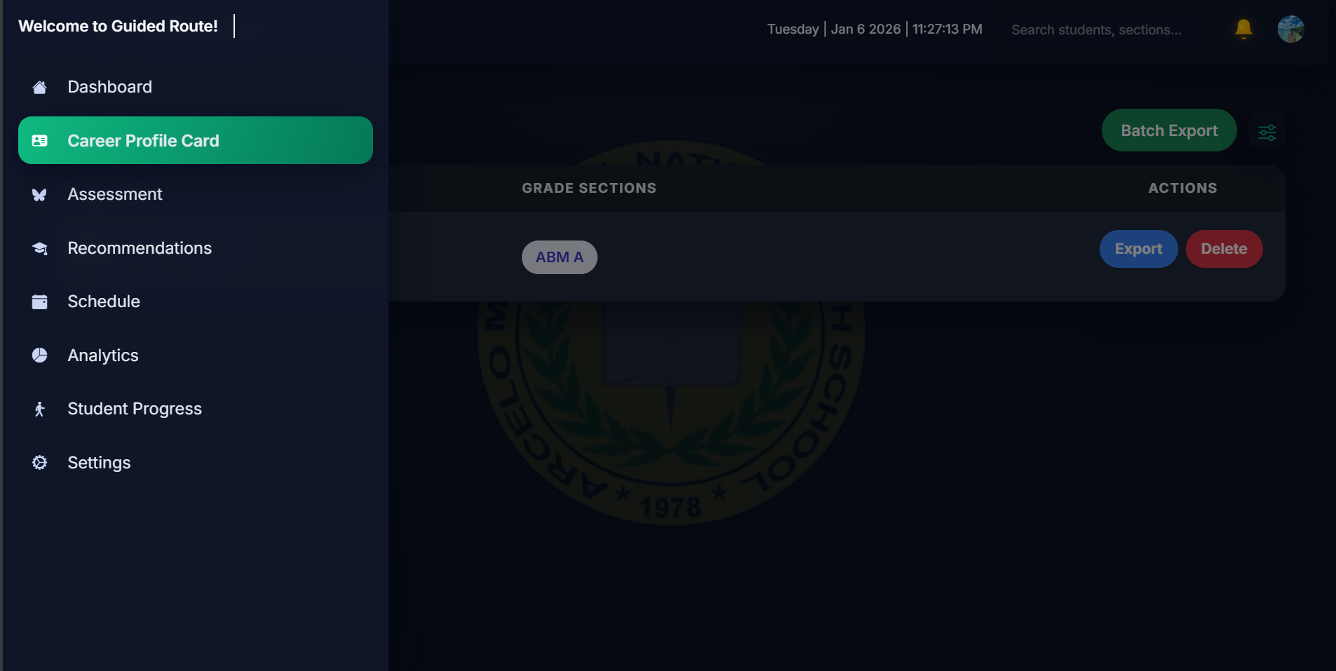
Figure 12: Career Profile Card

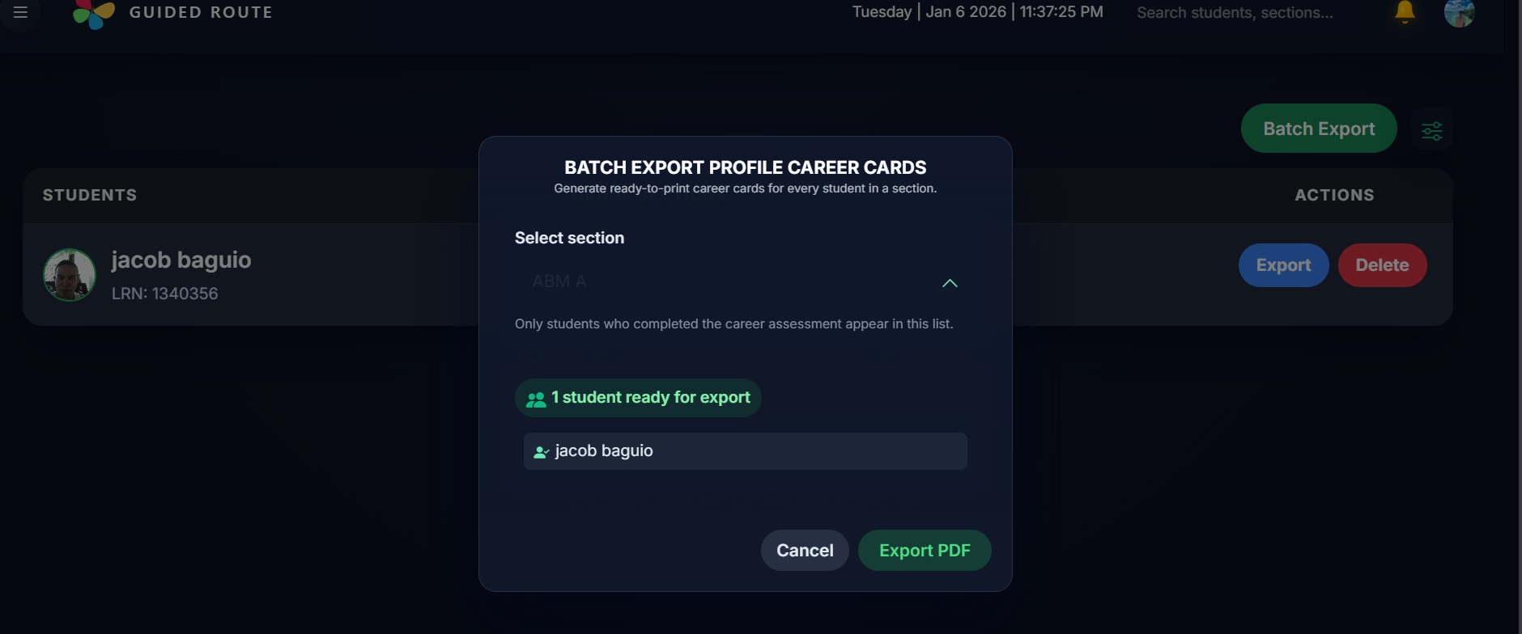
Figure 13: Career Profile Card – Batch Export

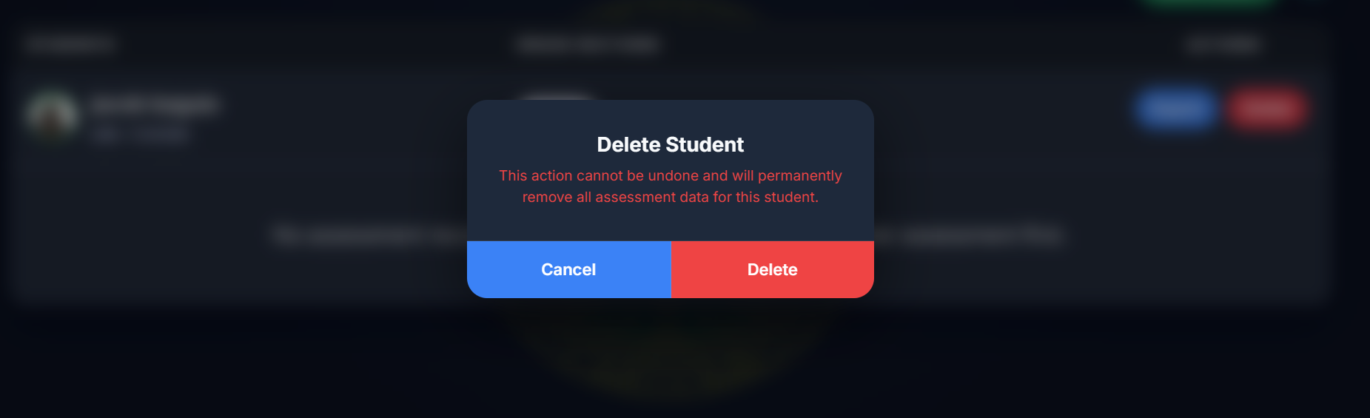
Figure 14: Career Profile Card – Delete Student

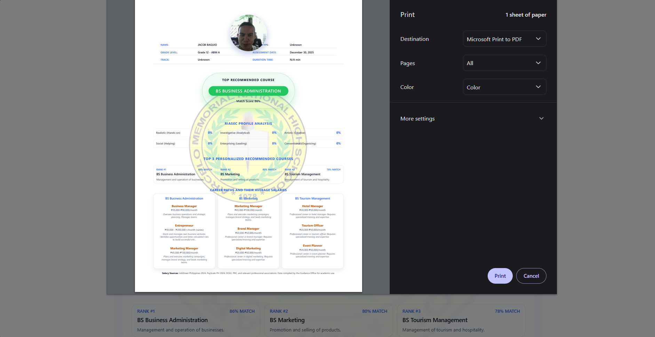
Figure 15: Career Profile Card – PDF Profile Career Card

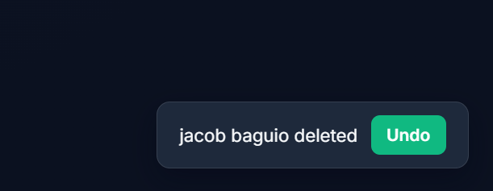
Figure 16: Career Profile Card – Undo Deletion

All of the figures from 12 and to 16 shows the Career Profile Card section, where records are organizing through different grade sections. The table lists sections like example "ABM A" with Export and Delete buttons on each row with working functionality to it.
Counselors have two choices for export options. The Export button beside a student's record, that is for generates a PDF for that individual. Batch Export, at the top-right, then produces a single PDF covering every student section.

The filter icon next to Batch Export shows the view by grade level, SHS track, or section name which turns to be useful when working with these specific group. Deleted records can be recovered through an Undo button that will appear after clicking the delete.

The left panel linking to the system of others. The header shows the current date and time and a search bar for finding specific students which I mentioned in figure before.
.

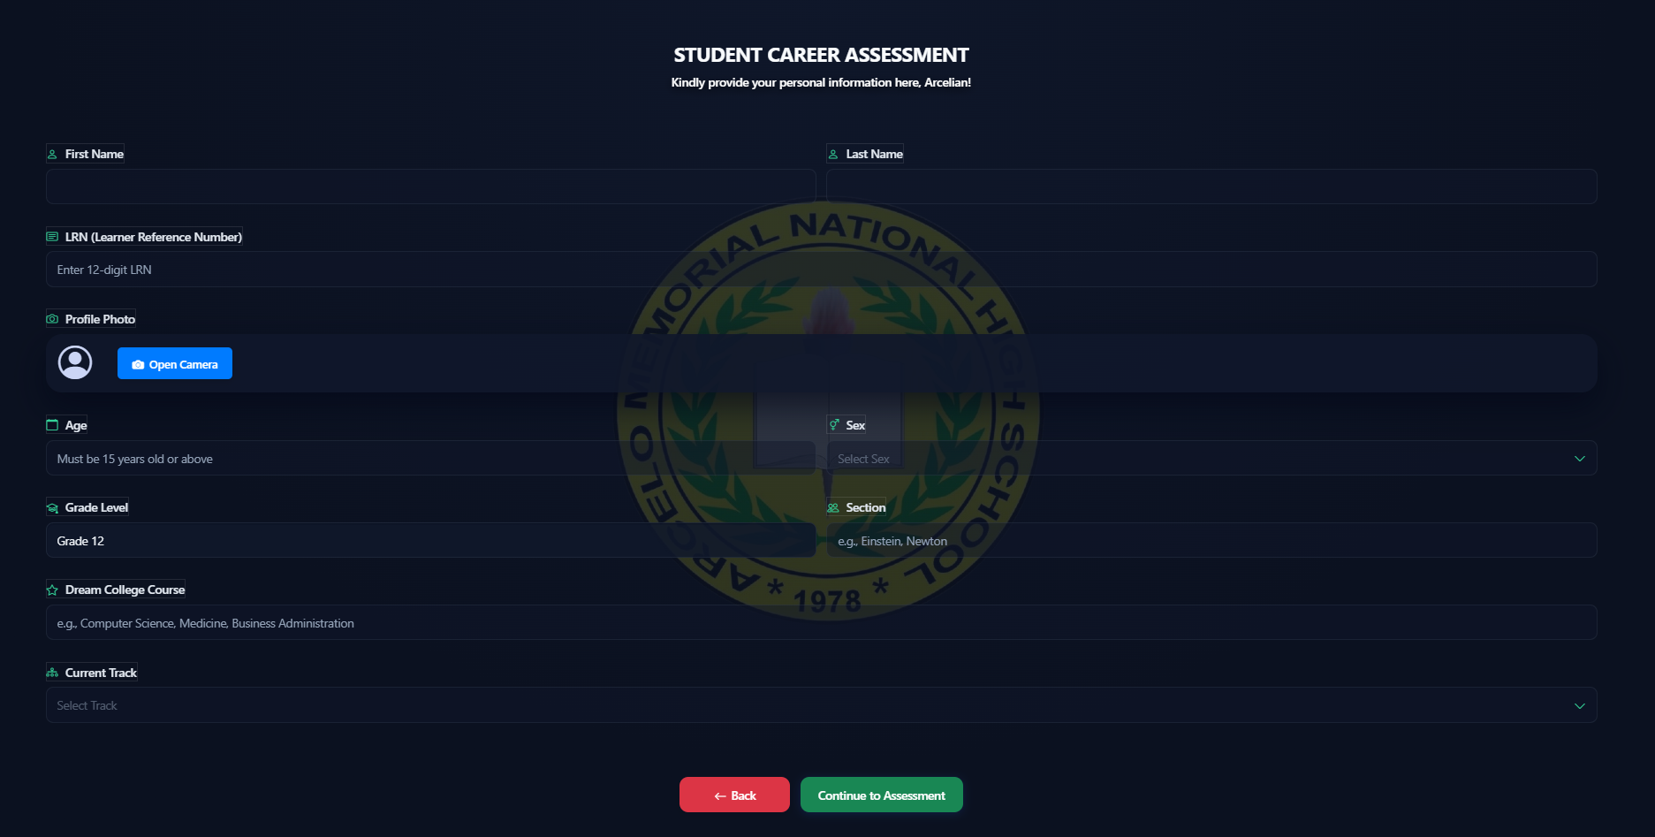

Figure 17: Student Career Assessment Registration Form

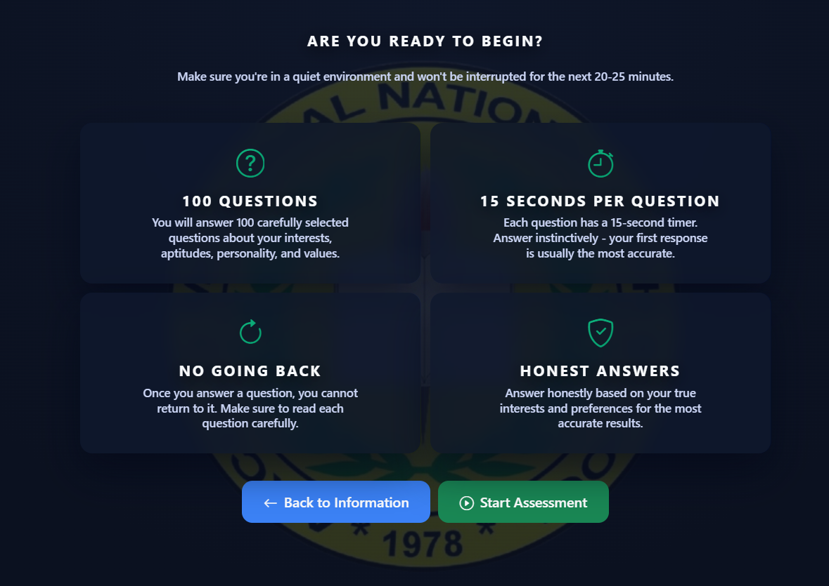
The figure 17 is showing the registration form that will appear when a student tries to take an assessment. It contains personal information and student can add their pictures which will be taken on site.

Figure 18: Assessment Instructions and Guidelines

Figure is showing the instructions before proceeding answering the test. It shows 100 questions, 15 seconds per questions, and cannot undo the answers. Also, it says to acquire accurate results, the students should also answer it with all honesty.
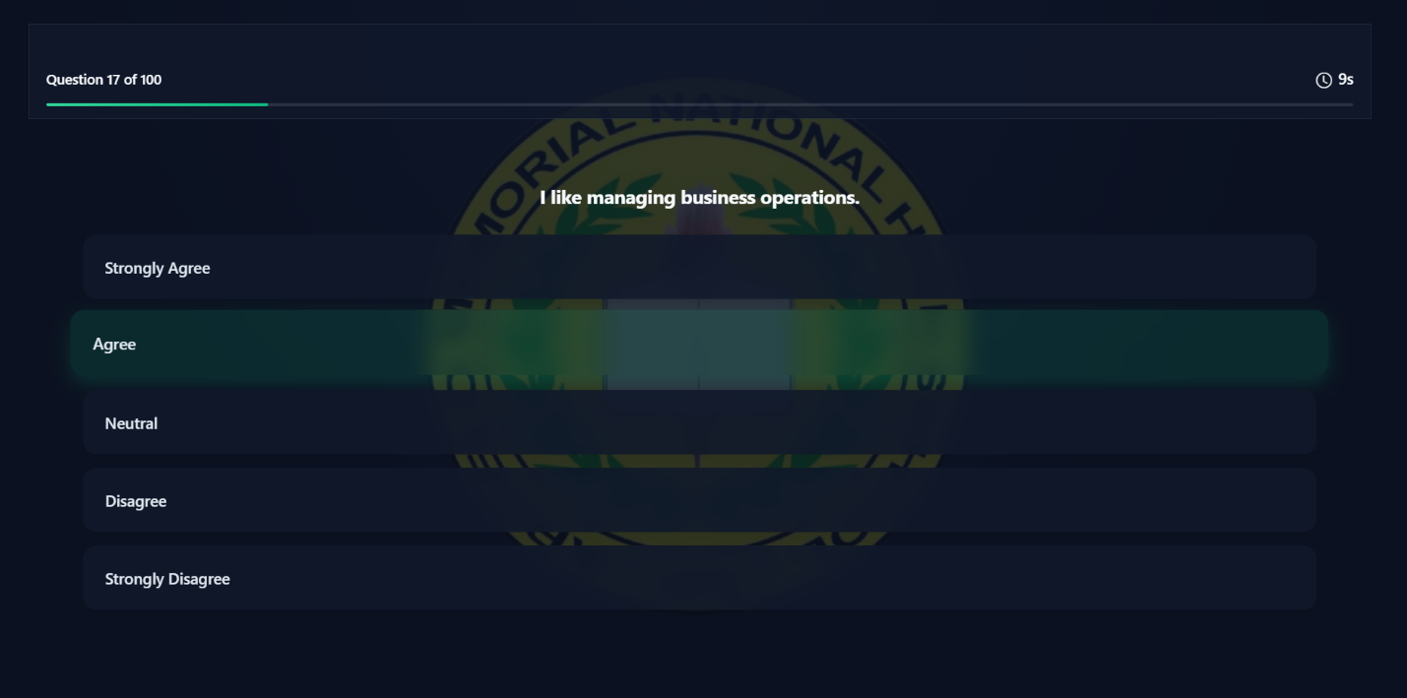
Figure 19: RIASEC Assessment Question Interface
Figure 19 shows one of the example questionnaires. The layout of the choices and questionnaires are properly placed to avoid confusion and also to answer quickly.
.
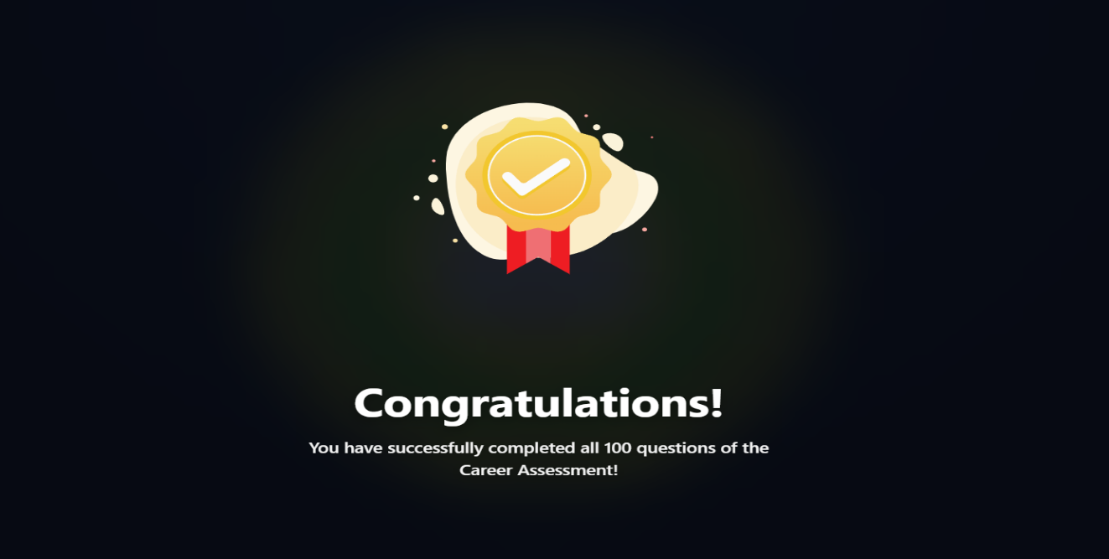
Figure 20: Assessment Completion Confirmation

Figure 20 is showing what comes after answering the 100 questions. The system will display a congratulatory celebration right after answering all.
.
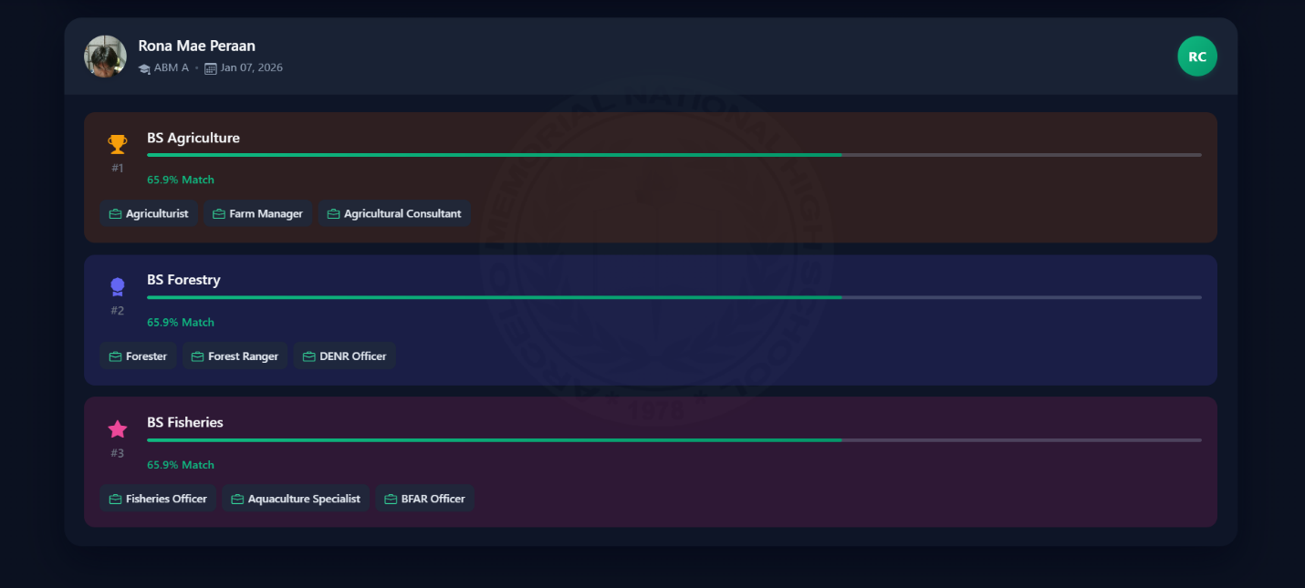

Figure 21: Course Recommendations Results

The figure 21 apparently shows an example student with their top 3 courses based on their exam results. There is a clear different to the 3 courses and which one stands on top. There is also a progress bar that indicates the percentage it matches.
.

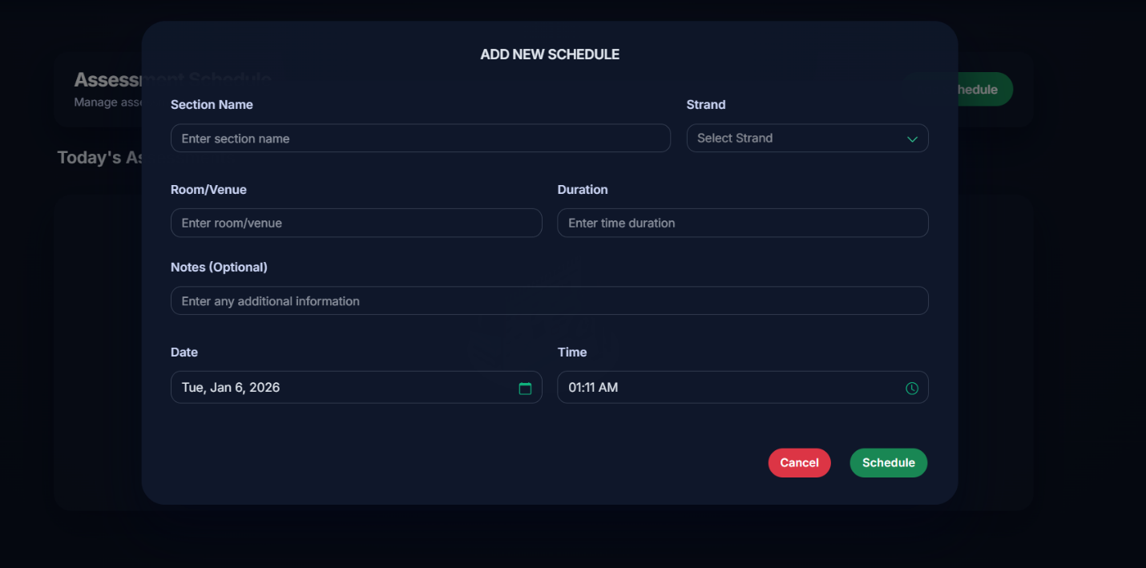
Figure 22: Add New Schedule Modal

Figure 22 is about adding new schedule. It has schedule and cancel buttons as well as common schedule information to be fill out.
.

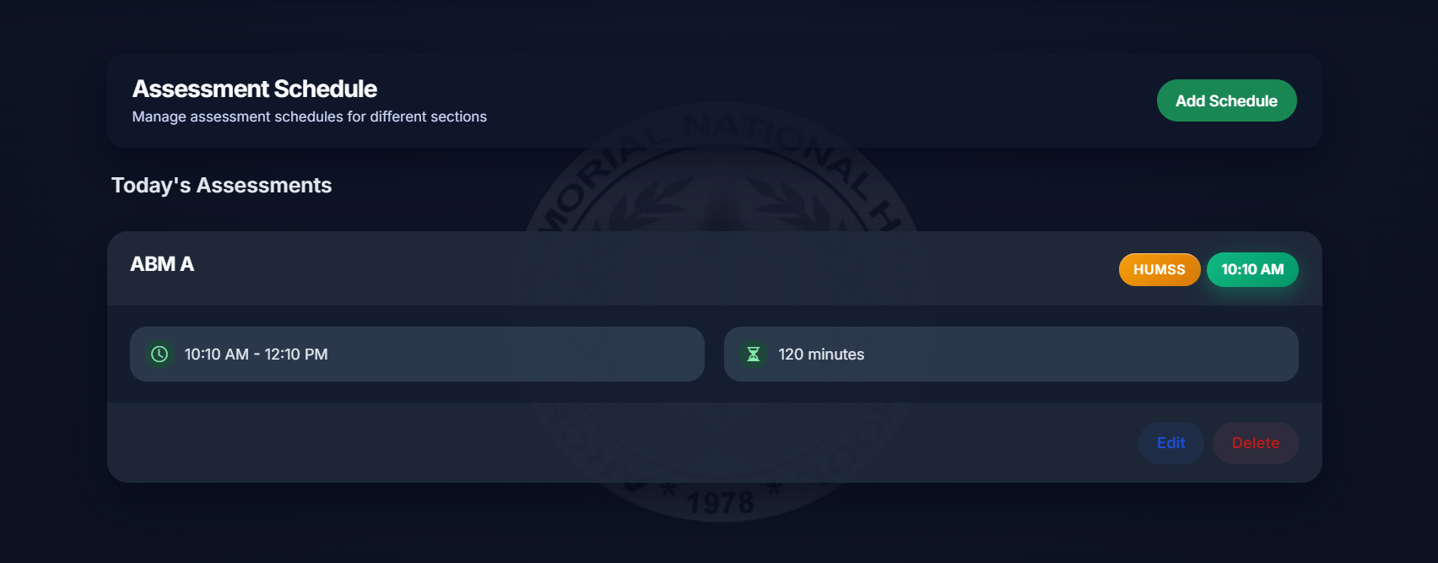
Figure 23: Assessment Schedule Management

In figure 23 is where it will display the added schedules in a horizontal drawer. It shows the strand, time, and the duration of how long it will take.
.

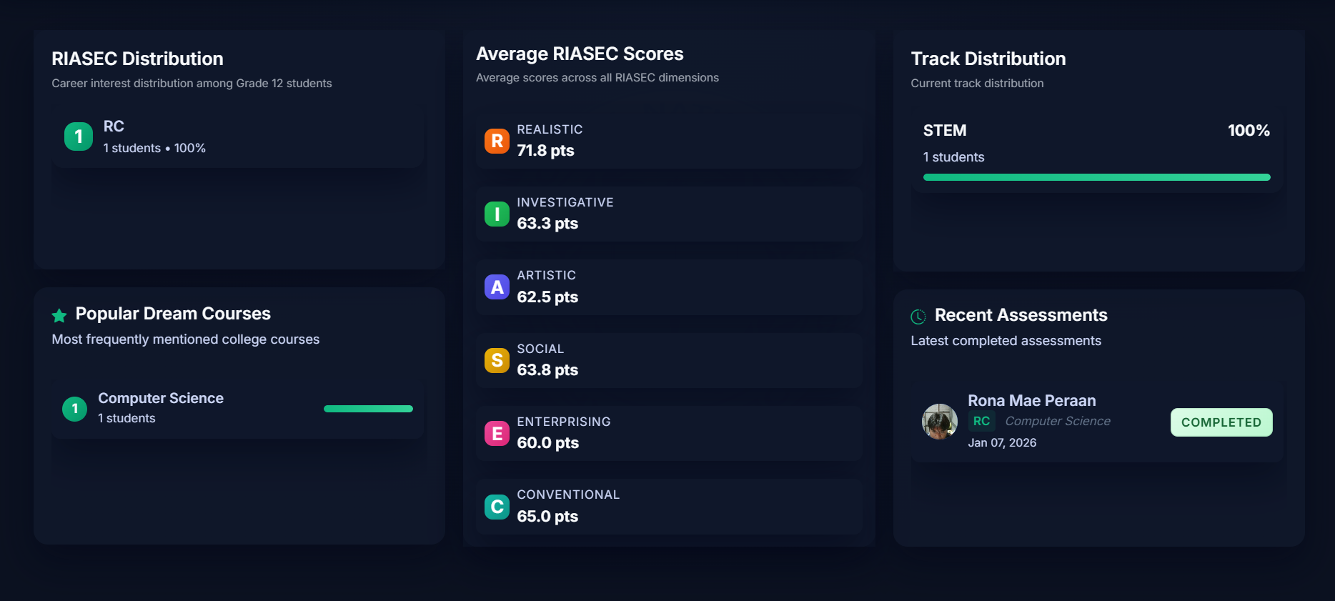
Figure 24: Analytics Dashboard

Figure 24 is the analytics dashboard and its contents. It shows riasec distribution, popular dream courses, average riasec socres, track distribution, and recent assessments that is clearly organized without overlapping information within each other.
.

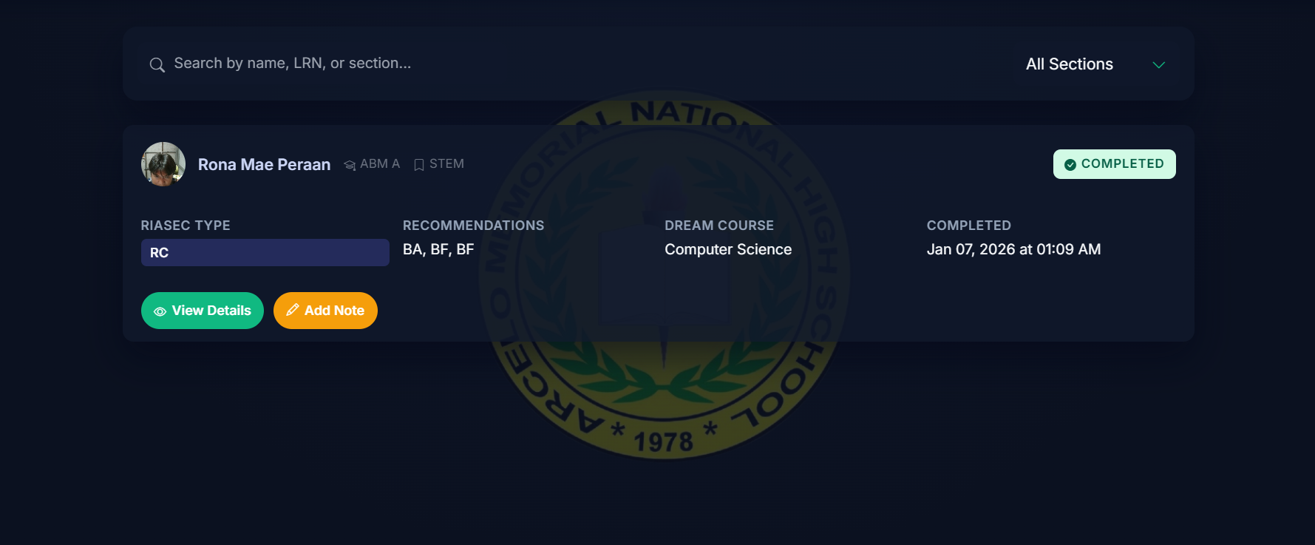
Figure 25: Student Progress Monitoring

Figure 25 shows the student progress. It will display if that student completed the assessment, and view details as well as counselor can add notes for that specific student.
.

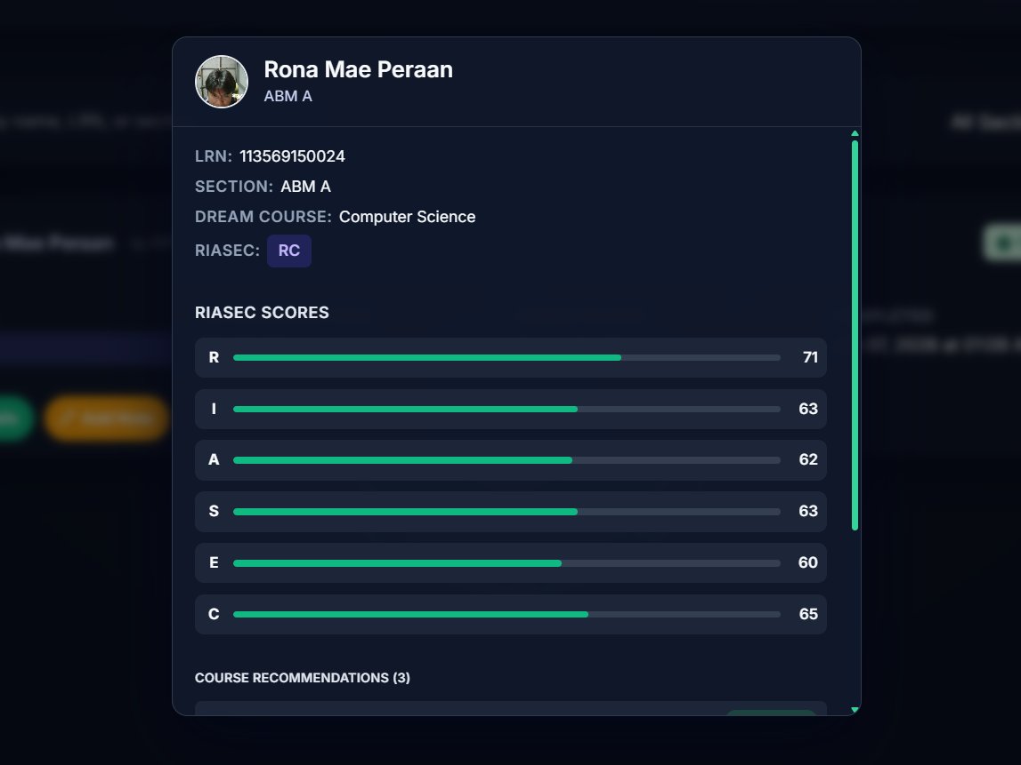
Figure 26: Student Profile Details

Figure 26 shows the full information which is Student Profile. It shows LRN, SECTION, DREAM COURSE, RIASEC CODES, as well as the course recommendations below.
.

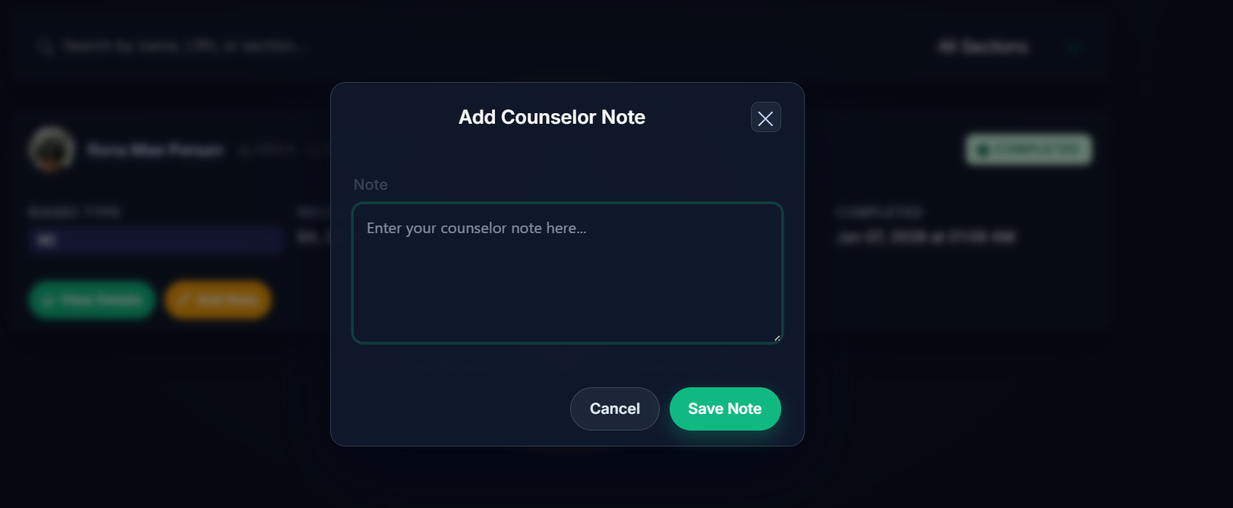
Figure 27: Add Counselor Note

Figure 27 shows the add counselor note modal. It lets the guidance counselor to add or save any notes for that specific students that uniquely identify that specific student.
.

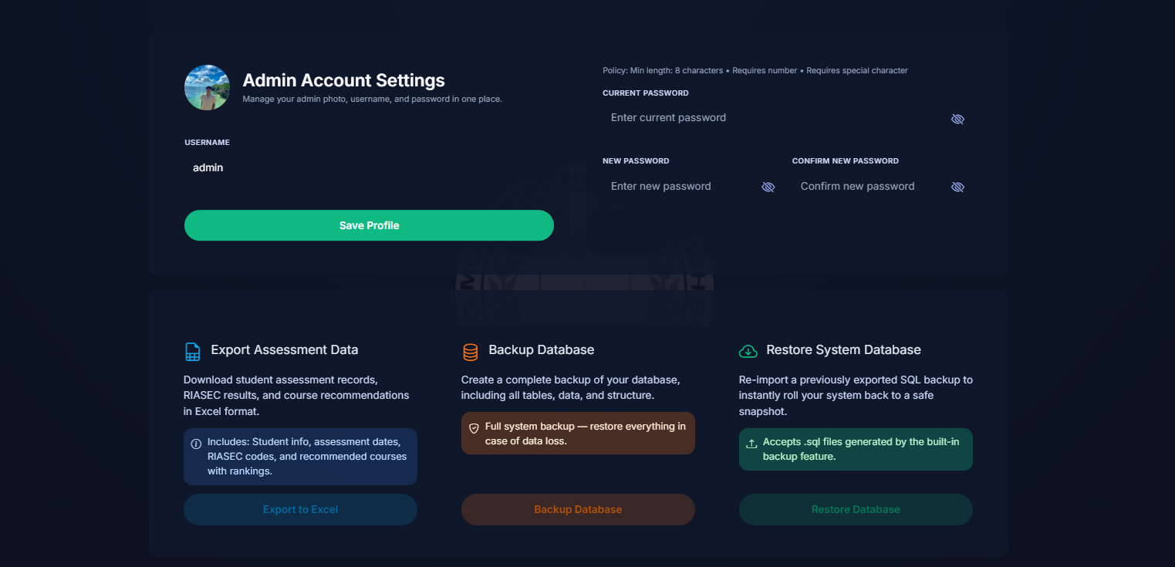
Figure 28: System Administration and Settings

Figure 28 is showing the settings intended only for the Admin side. It lets the administrators to export data, restore and backup the whole database, as well as change email and password considering the changes will be made also for the admin’s photo.
.
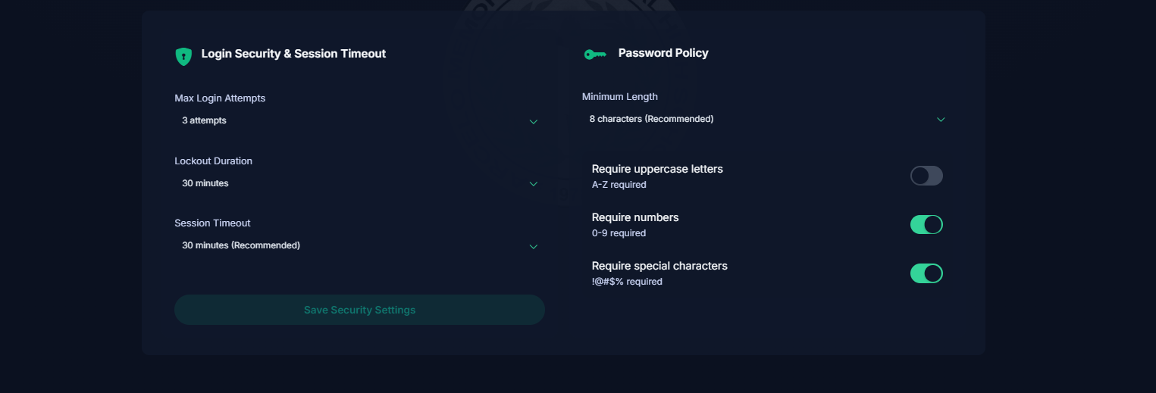

Figure 29: Advanced Security Configuration (Settings)

Figure 29 shows the extension of the settings for Admin. It shows login security and session timeout as well as password policy which is pretty standard when making any system to ensure security is one of the highest priority.

Entity Relationship Diagram
This diagram shows all the entities in Guided Route and the relationships between them and how the database is organized and what connects to what it portrays.
.
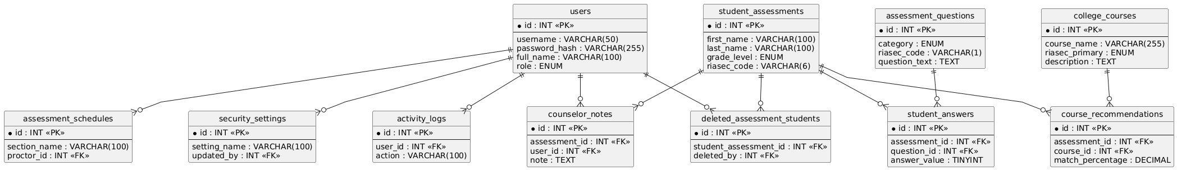

Figure 30: ERD

Data Dictionary

Field Name | Data Type | Length | Null Characteristics
id | INT | - | No
user_id | INT | - | Yes
action | VARCHAR | 100 | No
section | VARCHAR | 50 | Yes
details | TEXT | - | Yes
ip_address | VARCHAR | 45 | Yes
user_agent | TEXT | - | Yes
created_at | TIMESTAMP | - | No

Table 4: activity_logs

Field Name | Data Type | Length | Null Characteristics
id | INT | 11 | No
category | ENUM | - | No
riasec_code | VARCHAR | 1 | Yes
question_text | TEXT | - | No
created_at | TIMESTAMP | - | No

Table 5: assessments_questions

Field Name | Data Type | Length | Null Characteristic
id | INT | 11 | No
section_name | VARCHAR | 100 | No
grade_level | ENUM | - | No
track | ENUM | - | No
strand | VARCHAR | 100 | Yes
assessment_date | DATE | - | No
assessment_time | TIME | - | No
duration_minutes | INT | 11 | No
duration | VARCHAR | 50 | No
room | VARCHAR | 100 | No
assessment_type | ENUM | - | No
room_location | VARCHAR | 100 | Yes
proctor_id | INT | 11 | Yes
status | ENUM | - | No
notes | TEXT | - | Yes
created_at | DATETIME | - | No
updated_at | DATETIME | - | No

Table 6: assessment_schedules

Field Name | Data Type | Length | Null Characteristics
id | INT | 11 | No
course_name | VARCHAR | 255 | No
course_code | VARCHAR | 50 | Yes
riasec_primary | ENUM | - | No
riasec_secondary | ENUM | - | Yes
score_r | TINYINT | 4 | Yes
score_i | TINYINT | 4 | Yes
score_a | TINYINT | 4 | Yes
score_s | TINYINT | 4 | Yes
score_e | TINYINT | 4 | Yes
score_c | TINYINT | 4 | Yes
description | TEXT | - | Yes
career_paths | TEXT | - | Yes
riasec_profile | LONGTEXT | - | Yes
created_at | TIMESTAMP | - | No

Table 7: college_courses

Field Name | Data Type | Length | Null Characteristics
id | INT | 11 | No
assessment_id | INT | 11 | No
user_id | INT | 11 | No
student_id | INT | 11 | Yes
note | TEXT | - | No
created_at | TIMESTAMP | - | No

Table 8: counselor_notes

Field Name | Data Type | Length | Null Characteristics
id | INT | 11 | No
student_id | VARCHAR | 50 | Yes
first_name | VARCHAR | 100 | No
last_name | VARCHAR | 100 | No
age | INT | 11 | Yes
sex | ENUM | - | Yes
grade_level | ENUM | - | Yes
section | VARCHAR | 100 | Yes
dream_course | VARCHAR | 255 | Yes
current_track | VARCHAR | 50 | Yes
photo | LONGTEXT | - | Yes
score_r | DECIMAL | 5,2 | Yes
score_i | DECIMAL | 5,2 | Yes
score_a | DECIMAL | 5,2 | Yes
score_s | DECIMAL | 5,2 | Yes
score_e | DECIMAL | 5,2 | Yes
score_c | DECIMAL | 5,2 | Yes
riasec_code | VARCHAR | 6 | Yes
assessment_date | TIMESTAMP | - | No
completion_time | INT | 11 | Yes
student_number | VARCHAR | 50 | Yes
student_email | VARCHAR | 255 | Yes
riasec_scores | LONGTEXT | - | Yes
total_score | DECIMAL | 10,2 | Yes
completed | TINYINT | 1 | Yes

Table 9: student_assessments

Field Name | Data Type | Length | Null Characteristics
id | INT | 11 | No
assessment_id | INT | 11 | No
course_id | INT | 11 | No
recommendation_rank | TINYINT | 4 | Yes
compatibility_score | DECIMAL | 10,2 | Yes
match_percentage | DECIMAL | 5,2 | Yes
Table 10: course_recommendations

Field Name | Data Type | Length | Null Characteristics
id | INT | 10 | No
student_assessment_id | INT | 10 | No
first_name | VARCHAR | 100 | No
last_name | VARCHAR | 100 | No
lrn | VARCHAR | 20 | No
profile_photo | LONGBLOB | - | Yes
age | VARCHAR | 10 | No
sex | ENUM | - | No
grade_level | VARCHAR | 20 | No
section | VARCHAR | 100 | No
current_track | VARCHAR | 50 | No
dream_course | VARCHAR | 150 | No
deleted_at | TIMESTAMP | - | No
deleted_by | INT | 11 | Yes
deletion_reason | VARCHAR | 255 | Yes
original_created_at | DATETIME | - | Yes

Table 11: deleted_assessment_students

Field Name | Data Type | Length | Null Characteristics
id | INT | 11 | No
setting_name | VARCHAR | 100 | No
setting_value | TEXT | - | Yes
description | TEXT | - | Yes
updated_at | TIMESTAMP | - | No
updated_by | INT | 11 | Yes

Table 12: security_settings

Field Name | Data Type | Length | Null Characteristics
id | INT | 11 | No
setting_key | VARCHAR | 100 | No
setting_value | TEXT | - | No
setting_type | ENUM | - | No
description | VARCHAR | 255 | Yes
is_editable | TINYINT | 1 | Yes
created_at | DATETIME | - | Yes
updated_at | DATETIME | - | Yes

Table 13: settings

Field Name | Data Type | Length | Null Characteristics
id | INT | 11 | No
assessment_id | INT | 11 | No
question_id | INT | 11 | No
answer_value | TINYINT | 4 | No
time_taken | INT | 11 | Yes

Table 14: student_answers

Field Name | Data Type | Length | Null Characteristics
id | INT | 11 | No
username | VARCHAR | 50 | No
password_hash | VARCHAR | 255 | No
full_name | VARCHAR | 100 | No
email | VARCHAR | 150 | Yes
role | ENUM | - | Yes
profile_picture | VARCHAR | 255 | Yes
is_active | TINYINT | 1 | Yes
created_at | DATETIME | - | Yes
updated_at | DATETIME | - | Yes
last_login | DATETIME | - | Yes

Table 15: users

Network Design
The network design is the process of planning each devices connecting and exchange the data. For our Guided Route, this means configuring the school’s very own computer lab, so students could easily access and complete assessments through a shared local network without internet.

Network Model
A network model is showing basically how interaction of datas develop and how it moves between the resources , and how each device seems to know what they are really doing.
.
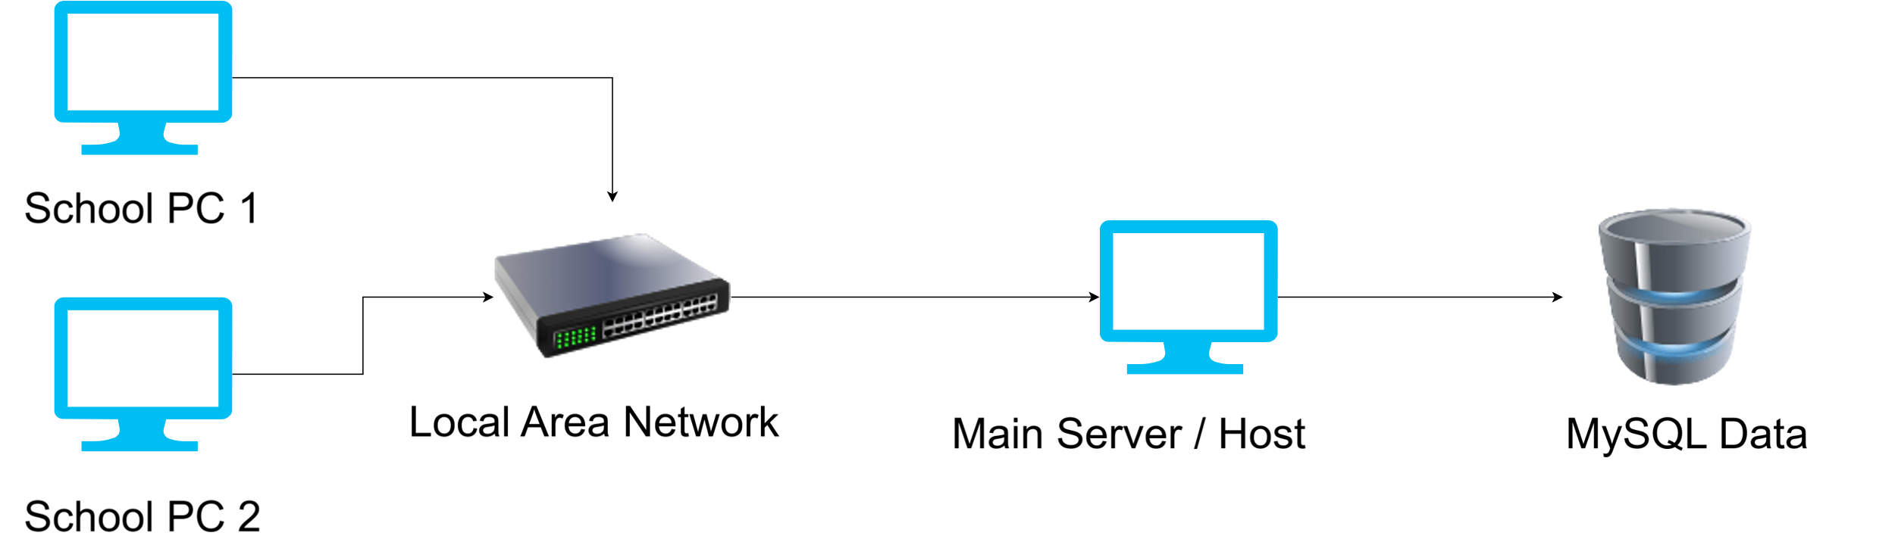

Figure 31 : Network Model

Guided Route keeps all student results and system settings in one database on the server side of the system. When a student tries to submits an answer or a counselor updates a record, that request goes direct through the LAN to the server and then the server writes to the database or even reading it. It depends in whatever it wants.
.

Network Topology
Network topology is just how the devices in a network are physically connected with proper coordination.
.
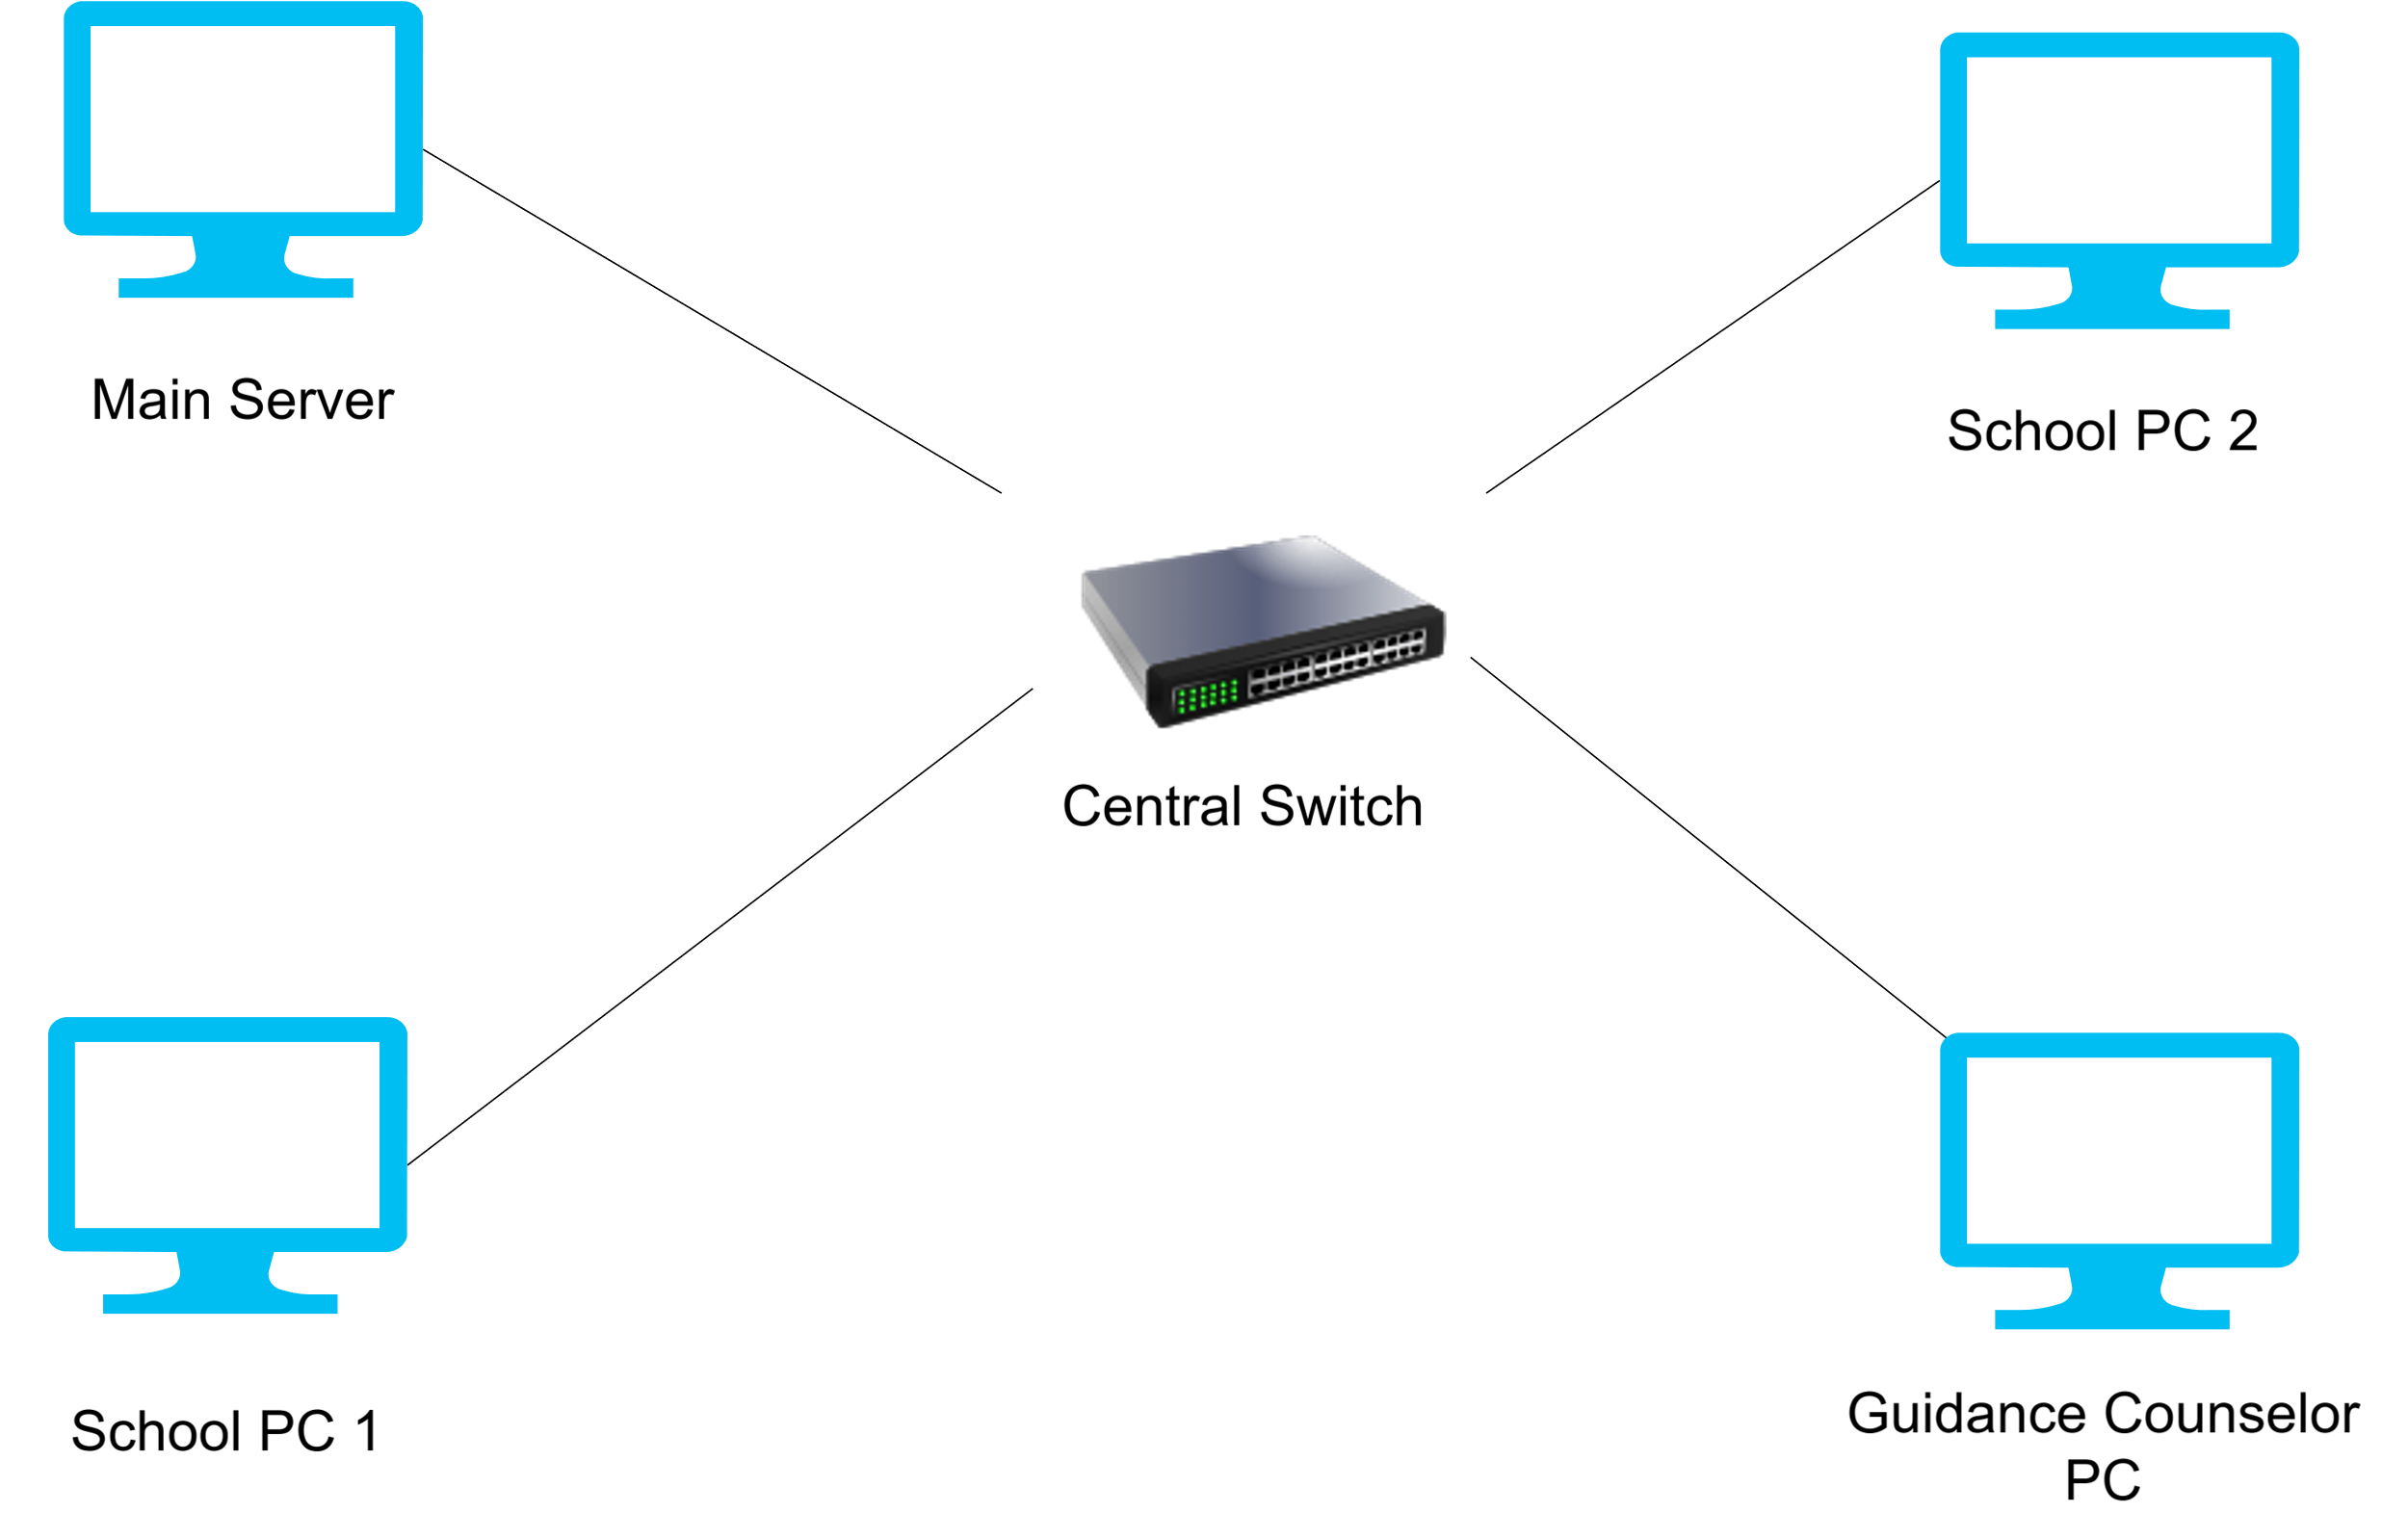

Figure 32: Network Topology

Our system Guided Route is using the star topology. Every workstation in the computer lab plugs into a common central switch. That switch handles all traffic between computers, and the server. Even if one computer might become a problem, it will not directly affect the others.
.

Development / Construction / Build Phase
This is the phase of developing the system with planning and clean execution too.

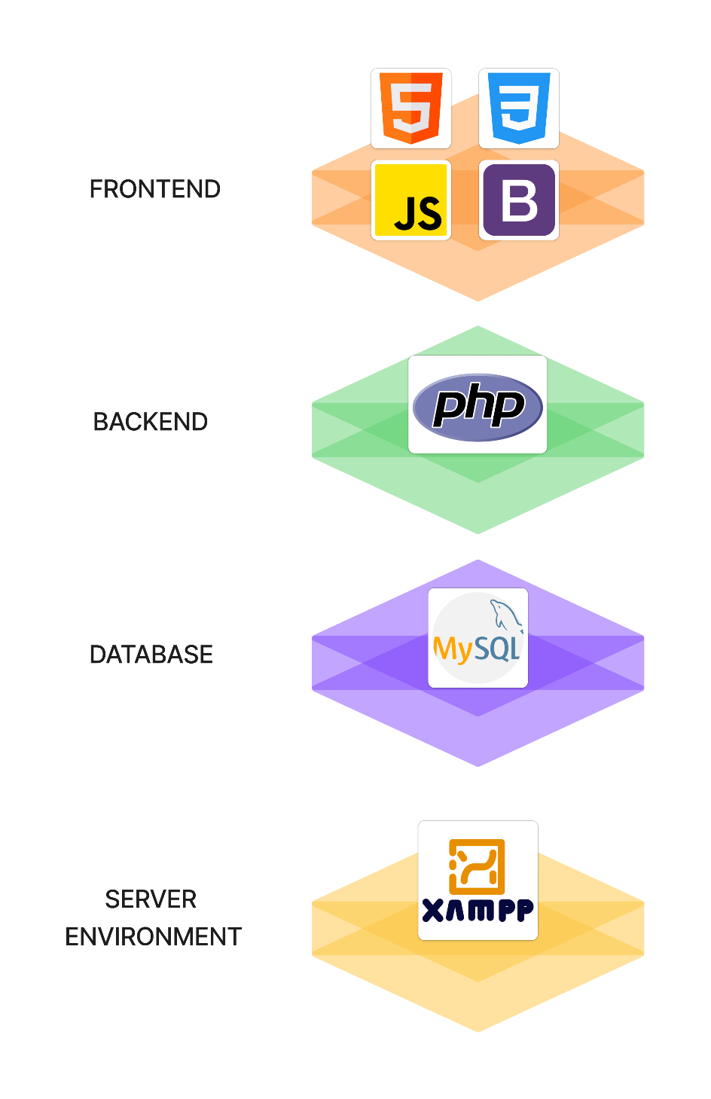
Technology Stack Diagram

Figure 33: Technology Stack Diagram

Frontend
We used HTML in the frontend to pair with cascading style sheets as it is easy to maintain and useful. It can make webpages lively especially when partnered with CSS.

In Guided Route, we are using CSS too because it is very important to pair html with css for the designing and layout of the webpages to ensure clean and captivating when students or admin use the system.

Javascript is used in Guided Route for its dynamic and interactivity features that perfectly balances with html and css. These trio combination is one of the foundation in making the web pages in these modern age.

We also utilizes Bootsrap as it is full of various icons that we can choose to add in our system. It is also very easy to apply in the code and the icons look modern and stylish as well.

Backend
We uses the PHP to interact with our database and also for the server side processes. Although its old, but it is still used in many companies because the scripting language offers scalability paired with technical process.

Database
We also added the MySQL as the official databse manager which contains numerous important information for admin and students. It is one of the foundation too of the database industry.

Server Environment
For server environment, we used XAMPP as it already has phpmyadmin and mysql to connect easily which runs without even needing an internet connection.

Software Specifications
Software Specification aims to inform the readers properly and users about the system and its functions and specifications. It is also used to describes the functional and behavioral requirements of the software.

Component | Specification/Details
Operating System | Windows 10 / 11 (64-bit)
Development Tools | Visual Studio Code and XAMPP
Programming Language / Tech Stack | PHP, JavaScript, HTML, CSS
Framework | Bootstrap 5
Database | MySQL (MariaDB)
Web Browser | Google Chrome or Microsoft Edge

Table 16: Software Specifications Table

Hardware Specifications
Hardware Specification details the physical components required to run the application effectively in the computer laboratory environment and make it fully functional.

Component | Specification of Server | Specification of Client
Processor | Intel Core i5 or equivalent | Intel Core i3 or equivalent
Memory (RAM) | 8GB DDR4 or higher | 4GB DDR4 or higher
Storage | 500GB SSD (System & Database) | 250GB HDD/SSD
Network | Gigabit Ethernet Adapter | Fast Ethernet Adapter
Monitor | 19-inch LED Display | 19-inch LED Display
Input Devices | Keyboard and Mouse | Keyboard and Mouse

Table 17: Hardware Specifications Table

Program Specifications
This shows the specifications of the system Guided Route.

List of Modules

This is the official breakdown or the components created in creating the Guided Route system in simple visual.

TABLE 18
LIST OF MODULES
Programmer | Modules | STUDENT | COUNSELOR (ADMIN)
 | STUDENT ASSESSMENT MODULE
 | Fill Personal Information | *
 | Take Assessment (100 Items) | *
 | View Completion Message | *
Number of Points | (1 point per module per user) | 3

Programmer | Modules | STUDENT | COUNSELOR (ADMIN)
 | COUNSELOR MANAGEMENT MODULE
 | Login / Logout |  | *
 | Dashboard |  | *
 | Career Profile Card |  | *
 | Assessment |  | *
 | Recommendations |  | *
 | Schedule |  | *
 | Analytics |  | *
 | Student Progress |  | *
 | Settings |  | *
Number of Points | (1 point per module per user) |  | 9

 |  | STUDENT | COUNSELOR (ADMIN)
Number of Modules per User | (equals the number of points per user) | 3 | 9

Total Number of Modules | 12

Testing/Quality Assurance Phase
The testing/quality assurance phase explores the system, identifies any. defects, and meets the expectations, of a quality product like the Guided Route. This phase includes unit, integration, alpha, and acceptance testing.

Unit Testing
The process of testing individual units or components of a software application to ensure they function correctly without any problems. It also helps identify and fix errors as early as possible in the development phase, promoting code reliability and secured.

Table 19
UNIT TESTING

Student Module

Feature to Test | Validation Criteria | Date Tested | Passed or Failed | Passed after Retest | Comments
Fill Personal Information | Can input and submit student details (name, LRN, section, track) | November 17, 2025 | 1 | 1 | Student info saved successfully
Take Assessment | Can answer all 100 RIASEC questions and submit | November 17, 2025 | 1 | 1 | Assessment completed successfully
View Completion Message | Completion page displays after submission | November 17, 2025 | 1 | 1 | Thank you message displayed
Invalid Input Validation | Error message displayed for missing required fields | November 17, 2025 | 1 | 1 | Performed as expected

Counselor Module
Feature to Test | Validation Criteria | Date Tested | Passed or Failed | Passed after Retest | Comments
Login | Valid username and password | November 19, 2025 | 1 | 1 | Successfully logged in
Invalid Username/Password | An error message must be displayed | November 19, 2025 | 1 | 1 | Performed as expected
Logout | Can log out from the system | November 19, 2025 | 1 | 1 | Successfully logged out
View Dashboard | Can view dashboard overview with statistics | November 19, 2025 | 1 | 1 | Dashboard displayed successfully
View Career Profile Card | Can view student RIASEC results and details | November 19, 2025 | 1 | 1 | Profile cards displayed
Export Career Profile PDF | Can generate and download PDF report | November 19, 2025 | 1 | 1 | PDF exported successfully
View Recommendations | Can view course recommendations for students | November 19, 2025 | 1 | 1 | Recommendations displayed
Add Schedule | Can create new assessment schedule | November 19, 2025 | 1 | 1 | Schedule added successfully
Edit Schedule | Can modify existing schedule | November 19, 2025 | 1 | 1 | Schedule updated successfully
Delete Schedule | Can remove schedule from system | November 19, 2025 | 1 | 1 | Schedule deleted successfully
View Analytics | Can view assessment analytics and charts | November 19, 2025 | 1 | 1 | Analytics displayed
View Student Progress | Can view student completion status by section | November 19, 2025 | 1 | 1 | Progress displayed
Delete Student Record | Can delete student assessment data | November 19, 2025 | 1 | 1 | Student deleted successfully
Update Profile | Can update counselor profile information | November 19, 2025 | 1 | 1 | Profile updated successfully
Change Password | Can change account password | November 19, 2025 | 1 | 1 | Password changed successfully
View Activity Logs | Can view system activity logs | November 19, 2025 | 1 | 1 | Logs displayed successfully
Global Search | Can search for students across the system | November 19, 2025 | 1 | 1 | Search results displayed

Alpha Testing
The initial phase of software testing is wherre the application is tested internally of the development team like before releasing it. to a wider audience. It helps uncover any bugs, gather feedback, and refine the software system for a more stable beta releases.

Table 20

ALPHA TESTING

Graphical User Interface (GUI)
Test Criteria | Poor | Fair | Good | Very Good
Consistency (The user interface maintains. a consistent formatting style and uses the same icons throughout the system) |  |  |  | ✓
Reusability (The system contains reusable GUI components such as; familiar buttons, text, and other tools) |  |  |  | ✓
Forgiveness and Tolerance (The interface displays messages or confirmation prompts, that allow users to undo any critical actions) |  |  |  | ✓
Simplicity (The GUI design incorporates simple buttons, and clear, uncrowded messages on uncomplicated screens) |  |  |  | ✓
Readability (The interface features appropriate colors, font size, and style, that are convenient for the target users) |  |  |  | ✓
Clarity (The displayed error, help, and warning messages are clear, concise, and designed. to assist the user in operating the software) |  |  |  | ✓
User-friendliness (The GUI design must be user-friendly, by providing helpful, courteous, and non-offensive messages) |  |  |  | ✓

Functionality

Test Criteria | Poor | Fair | Good | Very Good
Accuracy (The system performs calculations and data processing correctly) |  |  |  | ✓
Completeness (All required features and functions are implemented) |  |  |  | ✓
Error Handling (The system handles unexpected inputs and errors gracefully) |  |  |  | ✓
Data Integrity (Data is stored and retrieved accurately without corruption) |  |  |  | ✓
Response Time (The system responds to user actions within acceptable time limits) |  |  |  | ✓

Acceptance Testing
The user conducted the acceptance testing to asssess specific attributes, ensure compliance with system specifications, confirm software stability, and identify any potential flaws early.

Table 21
ACCEPTANCE TESTING
Attribute being evaluated | Please check above the number only one for each attribute
Functionality: Does the system meet all the functionality prescribed by the manuscript given? | 5 4 3 2 1  Comment:
Robustness: Does the system operate without encountering errors and without requiring any adjustments? | 5 4 3 2 1  Comment:
Workmanship: Does the system fabrication reflect quality workmanship? | 5 4 3 2 1  Comment:
Usability: Is the system easy to use and navigate for the target users? | 5 4 3 2 1  Comment:

Legend:
5 – Excellent 4 – Very Good 3 – Good 2 – Fair 1 – Poor

Table 18 presents the evaluation of acceptance testing, specifically conducted with the Research Adviser, Prof. Rrj Noya Capuno

Chapter IV

SUMMARY OF FINDINGS, CONCLUSIONS, AND RECOMMENDATIONS

Guided Route is a web app that runs on the school's local network at Arcelo Memorial National High School. Grade 12 students take a RIASEC assessment and get course recommendations without a counselor having to score anything by hand.

The existing process was the starting point ; and the researchers talked to the guidance counselor and students who had gone through manual testing and what the process actually looked like, where it broke down, what students walked away without.
.

Findings
After career assessments, the manual scoring of the test results really slows the process and it took long that students might find it may be too overwhelming. Without online guidance system as unique as Guided Route, they may be bored to answer manually and might not answer questions with all honesty.

Guided Route is such a game changer in guiding students especially the grade 12 students. It can work offline, admins can utilize the feature and the students will find it interesting with the way the questionnaires are displayed, how quick the recommendations were, and the unique profile career card that focuses on each student alongside their results and recommended courses.
.

Conclusion
The Guided Route is a huge success when implement to many high school campus. It supervises the students learning with the help of a supervisor and engages with the students while they take their time answering the questions. It is a must to every campus especially for Grade 12 students as choosing the right college course also equates to choosing your future.

Recommendations
The researchers for now does not find any recommendations when applied. Maybe for future purposes, there might be some things to consider but as thing stands, the system is abundant only for the most importante features which was carefully considered.

References
Department of Education. (2015). DepEd Order No. 41, s. 2015: Senior High School Career Guidance Program and Early Registration. https://www.deped.gov.ph/wp-content/uploads/2015/08/DO_s2015_41.pdf
Department of Education. (2016). DepEd Memorandum No. 076, s. 2016: Senior High School Manual of Operations. https://www.deped.gov.ph/wp-content/uploads/2018/10/DM_s2016_076.pdf
Leung, S. A. (2022). New frontiers in computer-assisted career guidance systems (CACGS): Implications from career construction theory. Frontiers in Psychology, 13, 786232. https://doi.org/10.3389/fpsyg.2022.786232
Waller, S., Waller, L., Mpofu, V., & Kurebwa, M. (Eds.). (2020). Online career guidance systems for PK-12 school students: Compliments to a comprehensive school counseling program. In Education at the intersection of globalization and technology (pp. 1–25). IntechOpen. https://doi.org/10.5772/intechopen.95084
Maestrado, J. T., & Bucar, J. D. (2024). Career Guidance Advocacy Program and the Grade 10 Completers’ Career Choice. International Journal of Multidisciplinary: Applied Business and Education Research, 5(2), 1–15. https://www.ejournals.ph/article.php?id=22563
Agtani, J. B. (2021). Career Guidance Implementation of Public Secondary Schools of Benguet. DepEd E-Saliksik. https://e-saliksik.deped.gov.ph/wp-content/uploads/2022/03/CAR_2021_Agtani_Career-Guidance-Implementation-of-Public-Secondary-Schools-of-Benguet-1.pdf
Nadeem, M., Zaidi, S. K. H., Jawed, A., Haider, A., & Bhutto, A. R. (2023). Implementing a web-based career counseling and guidance system for high school students. International Journal of Engineering Research & Technology, 12(1), 103–115. https://www.ijert.org/research/implementing-a-web-based-career-counseling-and-guidance-system-for-high-school-students-IJERTV12IS010103.pdf
Leung, S. A., Ho, K. K., & Heller, K. A. (2022). Evaluation of the Infinity career planning and management system: A case study of computer-assisted career guidance in Hong Kong. Journal of Career Assessment, 30(2), 234–256. https://doi.org/10.1177/10690727211065492 (open access: https://pmc.ncbi.nlm.nih.gov/articles/PMC8886905/)

APPENDICES

CURRICULUM VITAE


___________________________________________________
PERSONAL INFORMATION
___________________________________________________
JENHO NACILLA
___________________________________________________
Address : Purok Limogmog, Curva
San Vicente Liloan, Cebu
Gender : Male
Age : 23
Date of Birth : June 11, 2002
Place of Birth : Liloan Cebu
Citizenship : Filipino
Civil Status : Single
Religion : Roman Catholic
Mobile Number : 09050410464
Email : nacillajenho@gmail.com
___________________________________________________
EDUCATIONAL BACKGROUND
___________________________________________________

Primary Education : Simeon Ayuda Elementary School
(2014-2015) San Vicente, Liloan, Cebu
Junior High School : Arcelo Memorial National High School
(2018-2019) Curva, San Vicente, Liloan, Cebu
Senior High School : Arcelo Memorial National High School
(2020-2021) Curva, San Vicente, Liloan, Cebu
Tertiary Education : Cebu Technological University – Consolacion
(Present) Gov. F.B. Harrison Ave., Nangka. Consolacion, Cebu


___________________________________________________
PERSONAL INFORMATION
___________________________________________________
RONA MAE T. PERAAN
___________________________________________________
Address : Sitio Lumbang, Pulpogan
Consolacion, Cebu
Gender : Female
Age : 23
Date of Birth : August 7, 2002
Place of Birth : Albasan, Claveria, Masbate
Citizenship : Filipino
Civil Status : Single
Religion : Roman Catholic
Mobile Number : 09358224378
Email : peraanronamae07@gmail.com

___________________________________________________
EDUCATIONAL BACKGROUND
___________________________________________________

Primary Education : Albasan Elementary School
(2014-2015) Masbate
Junior High School : Pulpogan National High School
(2018-2019) Pulpogan, Consolacion Cebu
Senior High School : Pulpogan National High School
(2020-2021) Pulpogan, Consolacion Cebu
Tertiary Education : Cebu Technological University – Consolacion
(Present) Gov. F.B. Harrison Ave., Nangka. Consolacion, Cebu


___________________________________________________
PERSONAL INFORMATION
___________________________________________________
ODIZA CELESTIAL
___________________________________________________
Address : Antonio Luna, Pulpogan,
Consolacion, Cebu
Gender : Female
Age : 24
Date of Birth : April 16, 2001
Place of Birth : Aurora, Zamboanga Del Sur
Citizenship : Filipino
Civil Status : Single
Religion : Roman Catholic
Mobile Number : 09555777581
Email : celestialodiza01@gmail.com

___________________________________________________
EDUCATIONAL BACKGROUND
___________________________________________________

Primary Education : Bliss Elementary School
(2014-2015) Bliss, Buug, Zamboanga Sibugay
Junior High School : Nanan National High School
(2018-2019) Nanan, Payao, Zamboanga Sibugay
Senior High School : Imelda National High School
(2020-2021) Imelda, Zamboanga Sibugay
Tertiary Education : Cebu Technological University – Consolacion
(Present) Gov. F.B. Harrison Ave., Nangka. Consolacion, Cebu

___________________________________________________
PERSONAL INFORMATION
___________________________________________________
LLOYD CRISTIAN SANDOY
___________________________________________________
Address : Villaroca St. 727, Poblacion Occidental,
Consolacion, Cebu
Gender : Male
Age : 22
Date of Birth : July 20, 2003
Place of Birth : San Fernando, Cebu City
Citizenship : Filipino
Civil Status : Single
Religion : Roman Catholic
Mobile Number : 09260854853
Email : crislloyd038@gmail.com

___________________________________________________
EDUCATIONAL BACKGROUND
___________________________________________________

Primary Education : Consolacion Central School
(2010-2016) Consolacion Cebu
Junior High School : Consolacion National High School - Day Class
(2016-2020) Consolacion Cebu
Senior High School : Consolacion National High School SHS - Day Class
(2020-2022) Gov.F.B. Harrison Ave., Nangka, Consolacion, Cebu
Tertiary Education : Cebu Technological University – Consolacion
(Present) Gov. F.B. Harrison Ave., Nangka. Consolacion, Cebu

___________________________________________________
PERSONAL INFORMATION
___________________________________________________
CHRIS DANIEL G. MANTUHAC
___________________________________________________
Address : Sitio Batong Danglag,
Consolacion, Cebu
Gender : Male
Age : 23
Date of Birth : July 29, 2002
Place of Birth : Line In Consolacion
Citizenship : Filipino
Civil Status : Single
Religion : Roman Catholic
Mobile Number : 09384711984
Email : manuixx131@gmail.com

___________________________________________________
EDUCATIONAL BACKGROUND
___________________________________________________

Primary Education : Central Consolacion Elementary School
(2014-2015) Poblacion Occidental, Consolacion, Cebu
Junior High School : Pulpogan National High School
(2018-2019) Consolacion Cebu
Senior High School : Pulpogan National High School
(2020-2021) Consolacion Cebu
Tertiary Education : Cebu Technological University – Consolacion
(Present) Gov. F.B. Harrison Ave., Nangka. Consolacion, Cebu

PSYCHOMETRICIAN CERTIFICATION

